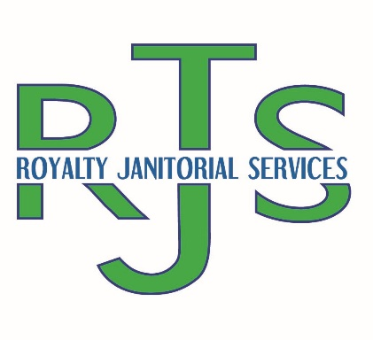
11427 Reed Hartman Hwy, Cincinnati, Ohio 45241
Office: 513-838-0063 | Fax: 513-838-0061 | Mobile: 513-463-8726
Email: duchessjanitorial@gmail.com | Website: www.duchessjanitorial.wixsite.com/website

About: Woman owned, black owned, small business located in Cincinnati, OH founded in July 2018. Providing residential and commercial (standard and deep) cleaning, construction (rough, spot, final and fluff) cleaning, sanitation and disinfecting services, and property management (grounds/litter cleaning, trash/clean outs, move out/in and turn) services to an array of communicates across Ohio, Kentucky, and Indiana.

WORK EXPERIENCE

Olive Branch a Dominium Management Company
October, 2021 to Present
Providing leasing office cleaning, clubhouse cleaning, exercise room cleaning, trash outs, townhouse turns, clean outs, move in/move out cleans, grounds cleanup and litter pickup

Reliable Equipment Sales (RES)
October 2021 to Present:
Providing weekly commercial janitorial cleaning services

Mills Fence Company
October 2021 to Present
Providing weekly commercial janitorial cleaning services

Dyantec Machine Inc
October 2021 to Present
Providing weekly commercial janitorial cleaning services

Alba Salon and Spa
April 2022 to Present
Providing weekly commercial janitorial cleaning services

