Redesign to Align  Business Development Consulting Services |  | PROFESSIONAL SERVICES  CAPABILITY STATEMENT
COMPANY OVERVIEW  Redesign to Align is a certified Minority Business Enterprise focused on providing workable solutions for a variety of business operations. We provide key talent to perform to analyze business needs, strategize solutions, create processes and procedures, implement change, and provide a complete evaluation of the outcomes to ensure effective success.  Redesign to Align is capable of providing services in the following areas: Professional and Administrative, Specialized Training, Marketing & Advertising, and more. |  | PRIMARY INDUSTRY  NAICS CODES
541611 – Administrative Management & General Management Consulting Services
541612 – Human Resources
Consulting Services
541618 – Other Management Consulting Services

Experience  The founders of Redesign to Align have served in various senior level capacities with prominent companies specializing in organizational rebranding, learning and development, Human Resource Management, and government contracting.  - 30+ years of collective professional experience  - Industry leading pricing  - Business Strategy & Planning Support  - Training Services  - Innovative and customized consulting solutions |  |  | Quality Commitment  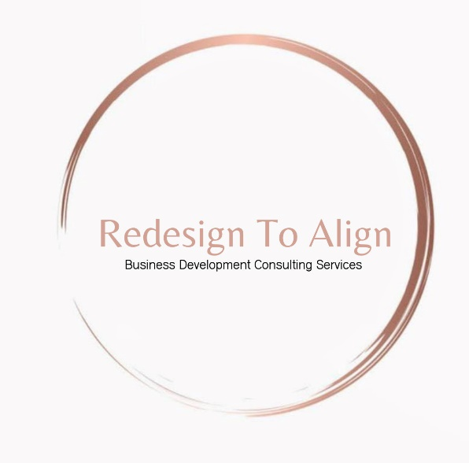  At Redesign to Align, we are committed to exceeding your expectations and ensuring your complete satisfaction. Our team of experienced Contractors work diligently with our customers to ensure the quality of our service is unparalleled and all performance metrics are met.
Company Profile | SET ASIDES: Minority-Owned Business  CONTACT: Cynthia Cowart & Teresa Lakes  EMAIL: ccowart@redesigntoalign.com  tlakes@redeigntoalign.com  PHONE: 1 (866)-421-9274  WEBSITE: http://www.redeigntoalign.com/

