REQUEST FOR PROPOSALS (RFP) No. P19002, Real Estate Appraisal Services
Attachment H (Google Earth Maps)

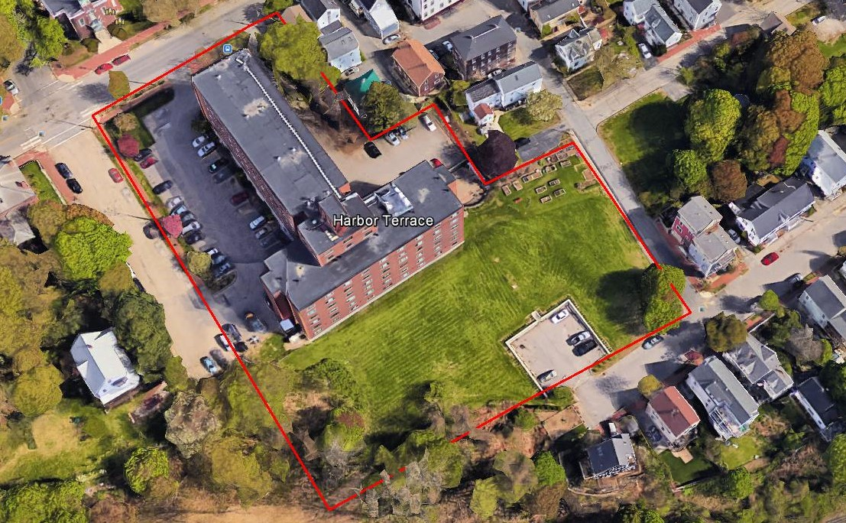
Harbor Terrace (120 units)

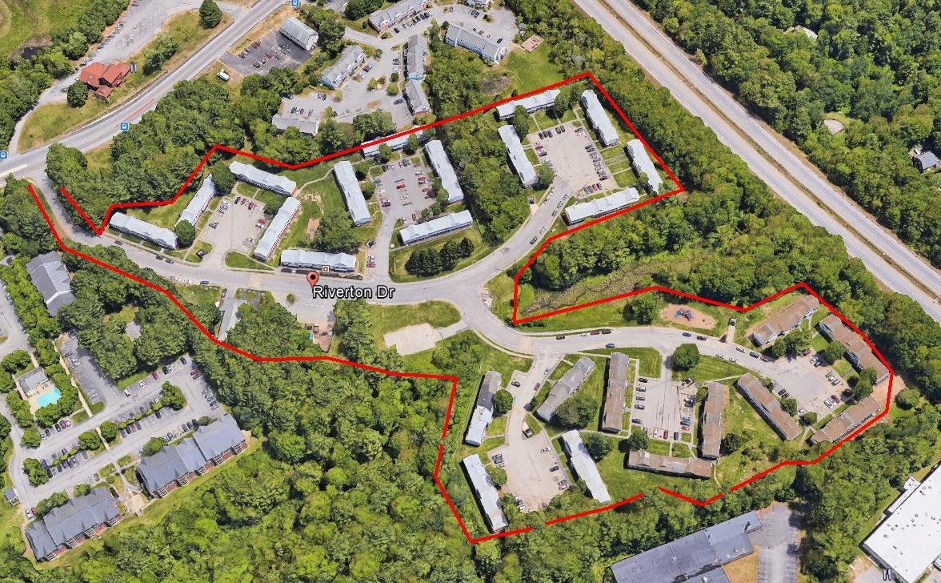
Riverton Park (150 units)
REQUEST FOR PROPOSALS (RFP) No. P19002, Real Estate Appraisal Services
Attachment H (Google Earth Maps)

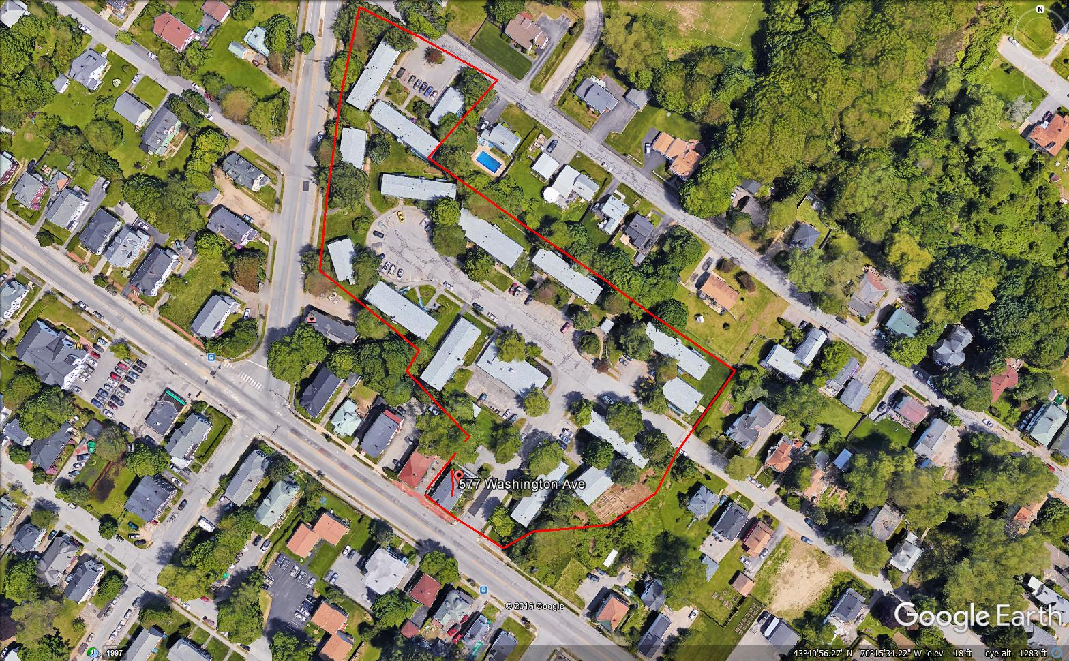
Washington Gardens (100 units)

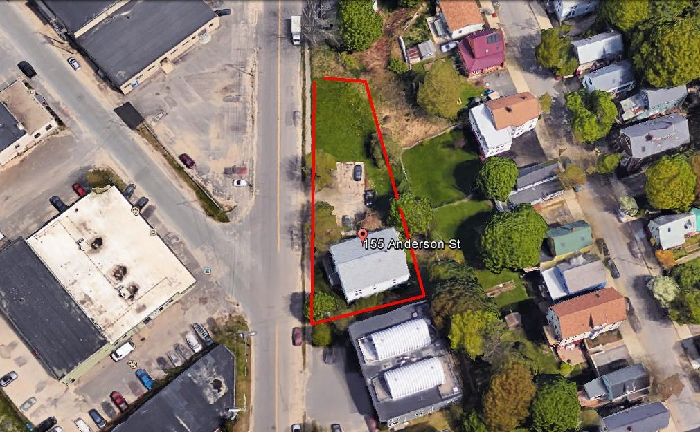
155 Anderson Street (6 Units)
REQUEST FOR PROPOSALS (RFP) No. P19002, Real Estate Appraisal Services
Attachment H (Google Earth Maps)

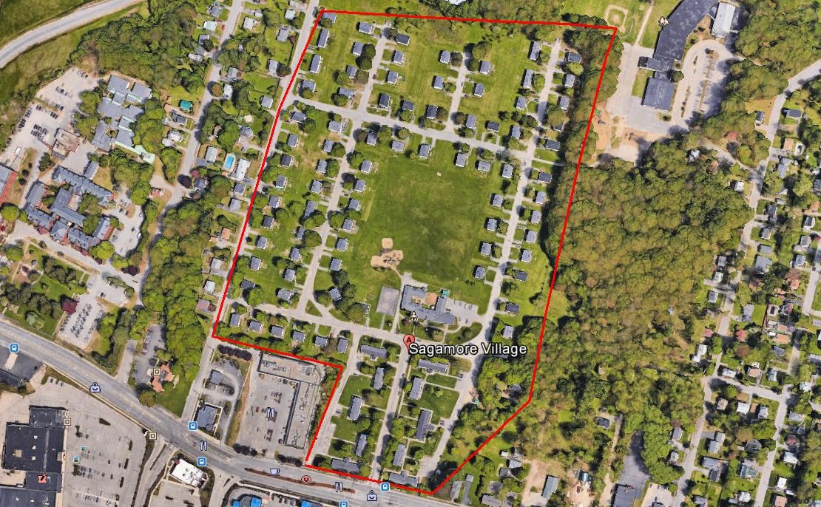
Sagamore Village (200 units)

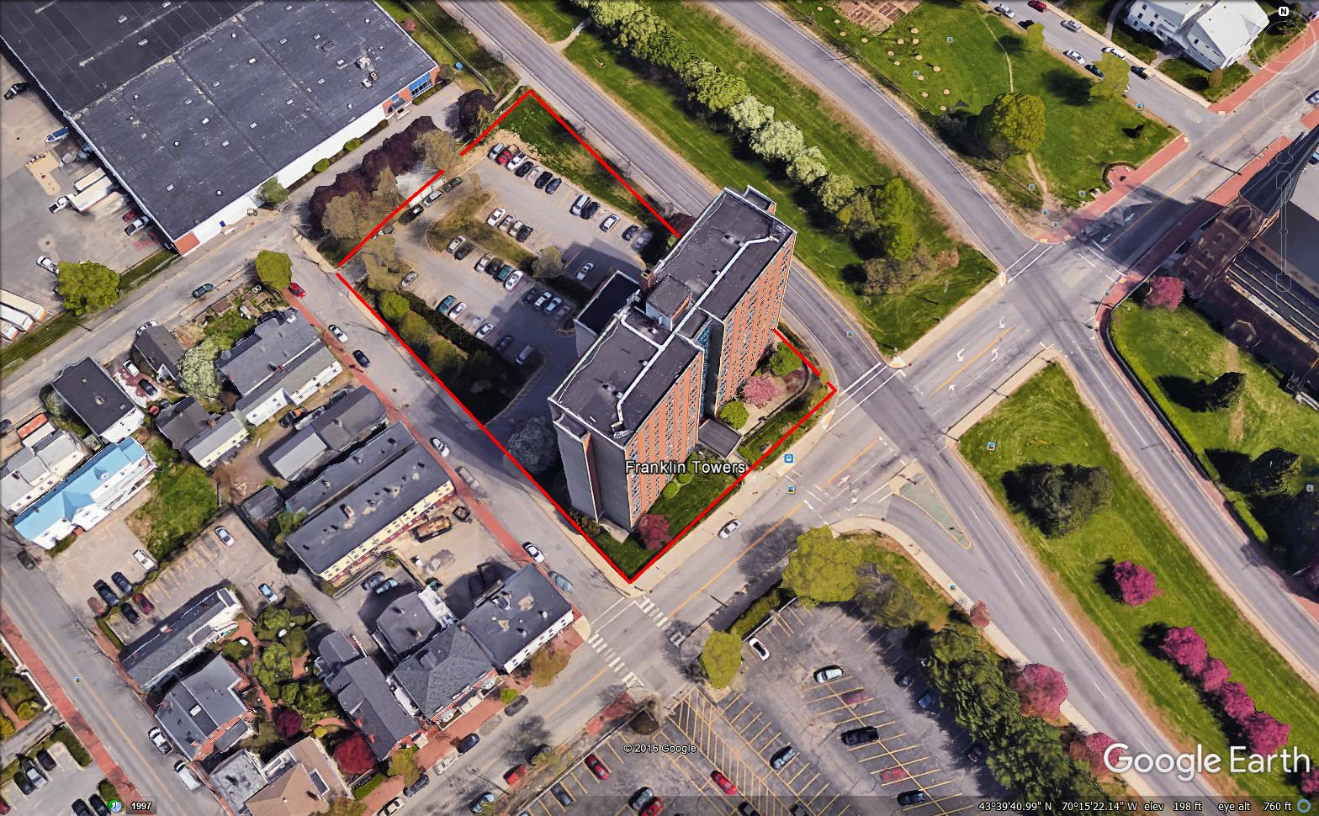
Franklin Towers (200 units)
REQUEST FOR PROPOSALS (RFP) No. P19002, Real Estate Appraisal Services
Attachment H (Google Earth Maps)

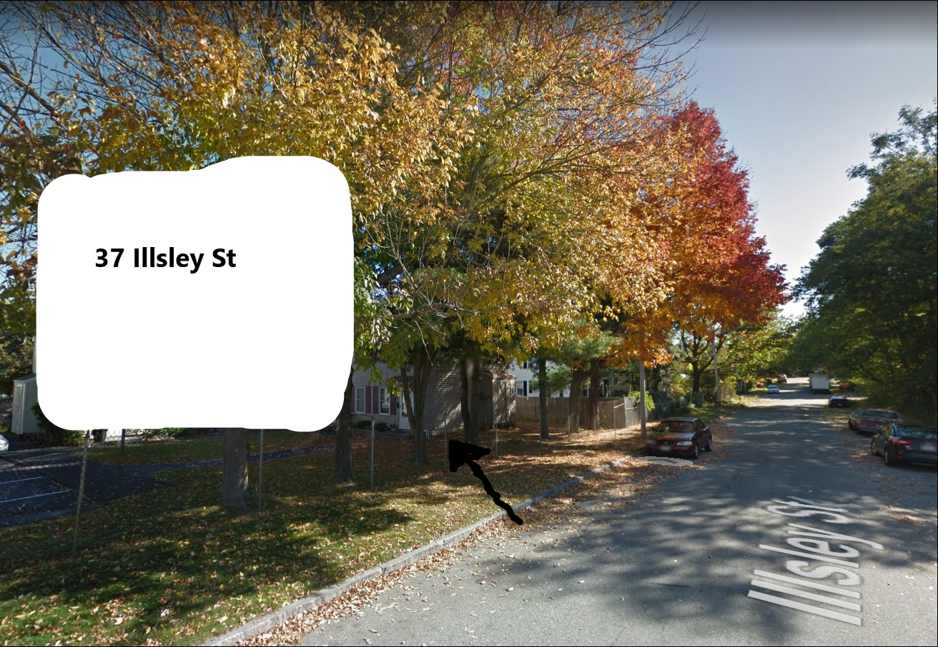
37 Illsley Street (Condo)

