REQUEST FOR PROPOSALS
LANDSCAPING SERVICES AT BUILDINGS OWNED OR MANAGED BY THE MUNICIPAL HOUSING AUTHORITY FOR THE CITY OF YONKERS

The Municipal Housing Authority for the City of Yonkers (“MHACY”) hereby solicits proposals from qualified firms for qualified firms for landscaping services on an as-needed basis for MHACY at various locations specified in the Request for Proposals (“RFP”).

This RFP package contains submission requirements and terms and conditions and other pertinent information for submitting a proper and responsive proposal. This RFP is the only information provided to prospective bidders (hereinafter “Responders”) and is available online starting October 5, 2020 at www.mhacy.org.

The RFP questions deadline is October 15, 2020 at 3:00PM Eastern Standard Time (EST). Any and all questions must be emailed to Juaquin Padilla at bids@mhacy.org by the deadline. No telephone calls and/or written communication sent via mail will be accepted.

Proposals must reach MHACY no later than 3:00 PM (EST) on October 22, 2020. Late submissions will be handled in accordance with the provisions in Form HUD-5369B.

Proposals will be evaluated on the criteria stated in the RFP. Negotiations may be conducted with contractors who have a reasonable chance of being selected for the award. After evaluation of the proposal revision, if any, the contract will be awarded to the responsible firm(s) whose qualifications, price and other factors are considered to be the most advantageous to MHACY. This is a non-exclusive contract. MHACY may award more than 1 Respondent a contract.

MHACY reserves the right to reject any and all proposals and waive any irregularities or informalities if it is in MHACY’s best interest to do so. MHACY reserves the right to cancel this RFP or to reject, in whole or in part, any and all proposals received in response to this RFP, upon its determination that such cancellation or rejection is in the best interest of MHACY.

MHACY is an Equal Opportunity Employer and does not discriminate on the basis of race, sexual orientation, color, national origin, sex, religion, age, disability, or family status. MHACY solicits and encourages the participation of minorities and small businesses in procurement.

Contact, related to this procurement, with members of MHACY’s Board of Commissioners, or MHACY’s officers and/or employees other than the contact person show above, during the procurement process could result in disqualification of a proposal.
Wilson Kimball
President & CEO
Municipal Housing Authority for the City of Yonkers
1511 Central Park Avenue
Yonkers, New York 10710
Project No. RFP 2020-09

1. INTRODUCTION
The Municipal Housing Authority for the City of Yonkers (“MHACY”) is a municipal housing authority duly authorized and validly existing under the laws of the State of New York operating under Federal and State housing laws. MHACY owns and manages a wide variety of properties, administers a Housing Choice Voucher Program, to provide affordable, stable, decent and safe housing opportunities within the City of Yonkers, New York. In pursuing our mission we work collaboratively with federal and state officials, and with the City of Yonkers, as their participation and assistance is essential in addressing the housing needs of families with very low income.
MHACY’s Board of Commissioners (the “Board”) has ultimate authority over the MHACY’s policies and procedures. Five Commissioners are appointed by the Mayor of Yonkers and two are elected by MHACY’s residents. The mayoral appointments serve for five years. The elected Commissioners – one to represent the Family Sites and one to represent the Senior Sites – are elected for a two year term. The Board while autonomous is responsible to the U.S. Department of Housing and Urban Development.
The Municipal Housing Authority for the City of Yonkers invites bidders to submit bids in accordance with the outlines and specifications contained in this RFP. This RFP contains specific requests for information. In responding to this RFP, bidders are encouraged to provide any additional information they believe is relevant.
The purpose of this procurement is to select a contractor for the provision of landscaping services at properties owned and/or managed by MHACY, all in the City of Yonkers, as more fully described and defined in this RFP. The contract is a non-exclusive contract for services. Selection may be made of one (1) or more Respondents deemed to be fully qualified and best suited among those submitting proposal. See “Exhibit A” for specifications and additional requirements.

2. SEQUENCE OF EVENTS
Event Date
Release of RFP October 5, 2020
Submission of Questions October 15, 2020
Bid Submission October 22, 2020 at 3:00 p.m.
Bid Evaluation October 23 to October 30
Contract Award November 2, 2020
The selection date is subject to extension at the discretion of the MHACY. The effective date of the contract is tentative as it is dependent on the selection date and the length of time for processing the contract.
The events identified in the schedule above are briefly described below.

- RFP Questions. The RFP questions deadline is October 15, 2020 at 3:00PM Eastern Standard Time (EST). Any and all questions must be emailed to Juaquin Padilla at bids@mhacy.org by the deadline. No telephone calls and/or written communication sent via mail will be accepted.

- Submission of Bids. One (1) sealed, signed copy of the Bid Form and supporting documentation shall be submitted to the MHACY at its Central Park Avenue address. Bids shall be in the format specified in Paragraph 5 of this RFP and signed by the authorized representative of the bidder. See Attachment B for “Bid Form”. Bids will be time-stamped upon receipt.
All bids shall be submitted in sealed envelopes clearly marked “Bid for Landscaping Services”.
Bids shall be addressed to:
Wilson Kimball, President & CEO
Municipal Housing Authority for the City of Yonkers
1511 Central Park Avenue
Yonkers, New York 10710
- Sealed Bids. A bid may be modified by a bidder prior to the deadline for submission of bids by delivery of a written modification to the above address. The sealed envelope shall be marked “Modification to Bid for Landscpaing Services” and list the name and address of the bidder.
A bid may be withdrawn prior to the deadline for submission of bids by delivering written notification to Wilson Kimball, President & CEO, Attention: Juaquin Padilla
Bids will be opened publicly on October 22 and recorded immediately thereafter at 3:00 p.m. at the first-floor conference room at 1511 Central Park Avenue.
- Evaluation of Bids. Bids will be evaluated by the MHACY staff using the criteria listed in Paragraph 6 of this RFP.
- Selection of Bidder. The contractor selected to perform the work and those contractors not selected will be notified by the MHACY. Selection does NOT constitute an obligation to contract with the successful bidder.

3. AMENDMENTS TO RFP
Amendments (addenda) to this RFP shall be in writing and shall be mailed electronically or by United States Postal Service to all individuals who received the RFP. Amendments shall be distributed with sufficient time to allow bidders to consider the amendments in preparing their bids. If necessary, the deadline for submission of bids will be extended by an amendment.
The written acknowledgment form mailed with the amendment shall be completed by the bidder and submitted with the bid as evidence of receipt of the amendment or shall be noted on the Bid Form.

4. CANCELLATION OF RFP — REJECTION OF BIDS
The MHACY reserves the right to cancel this RFP at any time and for any reason.
Any bid may be rejected in whole or in part when it is in the interest of the MHACY to do so. The MHACY shall not be responsible for the payment of any costs incurred by the bidder in the preparation or submission of a bid.
The issuance of this RFP, the receipt of a bid or the selection of a bidder in no manner obligates the MHACY to the eventual purchase of services. This process is solely at the discretion of the MHACY and may be terminated by MHACY without penalty or obligation at any time prior to the signing of a written contract.

5. BID FORMAT
Bidders shall use the Bid Form (Attachment B) and include the following additional information in their bid:
- Description and Manner in Performing the Work. The bidder shall provide a description of the equipment and process and methods that will be employed to provide the services described in the Scope of Work in “Exhibit A” of this RFP.
- Delivery of Service. The bidder shall state the anticipated delivery schedule for the work to be performed.
- Related Experience and Qualifications. The bidder shall include in the bid prior experience and qualifications related to accomplishing the Scope of Work contained in “Exhibit A” of this RFP; list at least three (3) contact names and phone numbers of prior clients, including government clients, if appropriate, that may be called for references; and note prior experience with buildings that are similar in size and scope of work to this project.

6. EVALUATION. Bids will be evaluated upon the following criteria:
Criteria | Maximum Points | Points
Conformity to specifications | 10
Respondents capability to meet the contract requirements | 35
Past and present work history as required in proposal | 35
Price | 20
Total Points | 100

During proposal evaluation, MHACY reserves the right to call for supplementary information from Responders and to meet with all or any one of them to clarify points of uncertainty or ambiguity. Responders agree to cooperate fully and promptly in providing such supplementary information or meeting requirements.

Proposals will be evaluated and ranked according to points received. MHACY, in its sole discretion, may invite selected Responders for an interview. Responders should be prepared to discuss the proposed scope of work, including availability of equipment and staffing, accounting and payment procedures, schedules, qualification of subcontractors proposed for portions of the work, and such other items as are directly related to the proposal.
MHACY also reserves the right to obtain clarification of any point in a Responder’s proposal or to obtain additional information necessary to properly evaluate a particular proposal. Failure of an Offeror to respond to such a request for additional information or clarification could result in rejection of the Responder’s proposal.
All selected Offerors will be invited to negotiate all aspects of the fee proposal to arrive at a firm and reasonable cost as determined by MHACY.

7. CONTRACT TERMS AND CONDITIONS
The contract between the MHACY and a successful bidder shall contain substantially the following terms and conditions. By submitting the Bid Form, the bidder agrees to these terms and conditions and the terms and conditions contained in Form HUD 5370 and the sample contract which is attached hereto and made a part hereof as Exhibit B. Any and all exceptions to the sample contract attached to this RFP should be noted in the Respondent’s response to this RFP. In the event additional services are required that have not been awarded, but are within the scope of the services described in this RFP, MHACY will have the sole and exclusive right to allocate the service to a firm under contract or seek the services on the open market, whichever is deemed to be in its best interest. The person signing the proposal on behalf of the Respondent must be authorized to commit the Respondent in contractual matters and to conduct negotiations or on behalf of the Respondent.
- Scope of Work. This portion of the contract will be drafted following the selection of an individual to perform the services. It will incorporate the Scope of Work in Attachment A of this RFP and the description of products and services from the bidder's bid.
- Compensation. The total “lump sum” bid price for completion of all activity set forth in the Project Scope. Compensation shall not exceed the limit specified in the contract for services provided for which the contractor is liable. The lump-sum price shall be specified in the contract. With each application for payment, the selected contractor shall submit waivers of mechanic’s lien(s) from any entity lawfully entitled to file a mechanic’s lien arising out of the work covered by the payment. 1. Submit partial waivers on each item for amount requested in previous application, after deduction for retainage (if any), on each item. 2. When an application shows completion of an item, submit conditional final or full waivers. 3. MHACY reserves the right to designate which entities involved in the work must submit waivers. 4. Submit final Application for Payment with or preceded by conditional final waivers from every entity involved with performance of the Work covered by the application who is lawfully entitled to a lien.
5. Waiver Forms: Submit executed waivers of lien on forms acceptable to MHACY.
6. The selected vendor shall indemnify and hold harmless MHACY, its officers, directors and employees from and against any and all actions, claims, and demands arising out of or related to the filing of mechanic’s liens against any MHACY property filed by the vendor’s contractors or subcontractors, as the case may be. In the event that a mechanic’s lien is filed in connection with the work, vendor shall secure a release or bond-off the lien claim within thirty (30) days of its filing.
- Term. The contract shall be effective on the date that the last of the parties to the contract signs the contract and will terminate as set forth in the contract.
- Termination. The contract may be terminated by either of the parties upon written notice delivered to the other party at least thirty (30) days prior to the intended date of termination. A party may not nullify obligations or liabilities already incurred for performance or for failure to perform prior to the date of termination.
- Status of Contractor. The contractor is an independent contractor performing services for MHACY and is not an employee of the State of New York (“State”). The contractor shall not accrue leave, retirement, insurance, bonding, or use of MHACY vehicles or any other benefits afforded to employees of MHACY by virtue of the contract.
- Assignment. The contractor shall not assign or transfer any interest in the contract or assign any claims for money due or to become due under the contract without the prior written approval of MHACY which consent may be withheld, conditioned or delayed. An approved assignment or transfer shall include a provision that binds the assignee or transferee to all terms and conditions of the contract.
- Subcontracting. The contractor shall not subcontract any portion of the services to be performed under the contract without the prior written approval of MHACY which consent may be withheld, conditioned or delayed.
- Records and Audit. The contractor shall maintain detailed records that indicate the date, time and nature of services rendered. These records shall be subject to inspection by the MHACY and State and / or Federal Auditors. MHACY shall have the right to audit billings both before and after payment. Payment under the contract shall not foreclose the right of MHACY to recover excessive or illegal payments.
- Release. The contractor shall, upon final payment of the amount due under the contract, release MHACY and, its officers, directors and employees from all liabilities, claims and obligations arising from or under the contract.
- Authority. The contractor agrees not to purport to bind MHACY to any obligation not assumed in the contract by MHACY, unless the contractor has express written authority from MHACY to do so, and then only within the strict limits of that authority.
- Conflict of Interest. The contractor shall warrant that the contractor has no interest and shall not acquire any interest, direct or indirect, that does or would conflict in any manner or degree with the performance of services required under the contract. The contractor shall further warrant that the contractor will not violate the provisions of City of Yonkers or State laws by entering into the contract.
- Amendment. The contract shall not be altered, changed or amended except by an instrument in writing executed by the parties.
- Merger. The contract shall incorporate all of the agreements, covenants and understandings between the parties concerning the subject matter. No prior agreement or understanding, verbal or otherwise, of the parties shall be valid or enforceable unless embodied in the contract.
- Applicable Law. The contract shall be governed by the laws of the State of New York.
- Appropriation. The terms of the contract are contingent upon sufficient appropriations and authorization being made available to MHACY for the purposes of project completion under the Federal RAD Program. If sufficient appropriations and authorization are not made by project financing sources, the contract shall, notwithstanding the provisions of any other section of the contract, terminate immediately upon the contractor's receipt of written notice of termination from MHACY. MHACY’s decision as to whether sufficient appropriations and authorization are made shall be accepted by the contractor and shall be final.
- Notice. MHACY Procurement Policy imposes civil and criminal penalties for its violation. In addition, the New York criminal statutes impose felony penalties for bribes, illegal gratuities and kickbacks.
- Equal Opportunity Compliance. Contractor shall agree to comply with all federal and state laws pertaining to equal employment opportunity. In accordance with all such laws, the contractor shall agree to assure that no person in the United States shall, on the grounds of race, color, national origin, sex, sexual preference, age or handicap, be excluded from employment with or participation in, be denied the benefits of or be otherwise subjected to discrimination under any program or activity performed under the Contract. If the Contractor is found not to be in compliance with these requirements during the life of the Contract, the Contractor shall agree to take appropriate steps to correct these deficiencies.
- Indemnity. The contractor shall hold harmless and indemnify MHACY, its officers, directors and employees against any injury, loss or damage, including cost of defense, arising out of the negligent acts, errors or omissions of the contractor and subcontractors and anyone directly or indirectly employed by any of them.
- Insurance. Contractor shall purchase and maintain insurance for protection from claims that may arise out of the contractor's operations under the contract, including operations by the contractor and subcontractors and anyone directly or indirectly employed by any of them, or by anyone for whose acts any of them may be liable. The certificate of insurance shall name MHACY an additional insured on all policies and a copy shall be filed with MHACY prior to commencement of the work. The limits of liability for the insurance required by this section shall provide coverage for not less than the following amount or greater if required by law:
Type of Coverage Required Minimum Limits of Liability
1. Workers' Compensation Statutory
2. Employer's Liability $500,000
3. Comprehensive General Liability (including personal $1,000,000 per occurrence ($2,000,000 general
(injury) aggregate and $2,000,000 aggregate)
4. Bodily Injury: One million dollars
($1,000,000) per person/one million dollars
($1,000,000) per occurrence and Property Damage; or combined single limit coverage of one million dollars ($1,000,000) per occurrence.
5. Automobile Liability; Covers all owned and non-owned vehicles $1,000,000 Combined Single Limit
Insurance Company must be licensed and admitted in New York State and a 30 day notice must be given to the MHACY in event of cancellation or change in coverage.

- Minimum Wage Rate Determination. MHACY anticipates a bid and subsequently entering into a contract with the successful bidder in excess of twenty-five thousand dollars ($25,000). Under Federal law the provisions of the Davis Bacon and Related Acts, (“DBRA”) requires that the Contractor and all subcontractors to pay Federal Davis Bacon prevailing wages to all trade workers on the project. A preliminary wage decision which is the current wage decision for Westchester County, New York is attached to provide bidders with approximate wage and fringe benefit data to be utilized in arriving at the contractor’s bid price. This wage decision will be updated with a final wage decision that will be in effect on the day that the construction contract is signed and the contractor is given a notice to proceed.

- Elations Systems Utilization. As a component of its procurement process, the MHACY has adopted a policy of requiring the successful bidder/contractor on construction contracts to utilize the “Elations Systems” wage reporting system for assuring strict compliance with DBRA requirements for all contracts in excess of $100,000. It is recommended that prospective bidders contact Elations Systems at: https://www.elationsys.com/ or by phone to determine pricing for the proposed project.
- Performance and Payment Bonds. Contractor shall deliver to the MHACY a 100% payment bond and performance bond upon execution of the contract.

- Required Project Close Out Manuals.
Each bidder must provide a list of all contractors, subcontractors and contact information including email, physical address and telephone contact information. Complete project turnover information must include as built, operations and maintenance manuals and warranty information for this project. This must be in the form of one (1) hard copy binder as well as one electronic copy delivered on a flash drive. Failure to do so may prevent consideration for the final payment.

- SOCIOECONOMIC CONSIDERATION: MHACY encourages and gives preference to companies located in or owned by persons residing in a public housing development (commonly referred as Section 3 companies). MHACY’s Affirmative Purchasing Policy also encourages bids from all small businesses including minority and woman owned businesses. A section 3 Business is a New York business at least 51% or more owned by a Section 3 resident or:
  - The New York registered business must have at least 30% permanent full-time employees that are Section 3 residents or that within the past 3 years were section 3 residents
  - A Section 3 resident is a public housing resident in Yonkers with an income no greater than 80% of the median income for Yonkers.
8.0 Submission Requirement Summary
Proposals, whether hand delivered or mailed shall be delivered directly to:

The Municipal Housing Authority for the City of Yonkers
1511 Central Park Avenue
Yonkers, NY 10710

With the following clearly noted on the lower left side of the submission envelope

Request for Proposals/Invitation to Bid – RFP/RFP 2020-09
The Municipal Housing Authority for the City of Yonkers
Bid for Landscaping Services
Attn: Juaquin Padilla

RFP Sealed Bid Opening
Sealed bids will be opened and recorded immediately thereafter on October 22, 2020 at 3:00 p.m. at the offices of the Municipal Housing Authority for the City of Yonkers at 1511 Central Park Avenue, Yonkers, NY 10710.

Required RFP/Bid Submittals
The following is a description of the minimum information which must be supplied by each contractor in their sealed bid package. Contractors are allowed to give such supplementary facts or materials that they consider may be of assistance in the evaluation of the proposal submitted. Proposals that omit critical elements may be considered nonresponsive. Proposal packages must contain, at a minimum, the following information and materials:

- Manufacturing specification sheet on all proposed hardware to be installed on the project.
- Completed bid forms that are contained in the Attachments to the RFP – Attachment A [initialed] and Attachments, B, C, & D [signed]
- Electronic copy of your proposal on a CD, DVD or flash drive.
- An initialed copy of each page of the RFP showing you have read the conditions and understand them, attach a page of exceptions, if any.
- A complete cost proposal that breaks all work to be completed down individually by location.. Any and all costs not specifically provided for in the proposal response will be borne by each Contractor.
- A proposed project schedule broken out by calendar weeks and months from the date of notice to proceed.

Attachment A

SCOPE OF WORK —

Spring cleanup to include:
- Removal of any leaves left over from fall cut back any winter growth on plants, shrubs and bushes
- Rake and loosen compacted soil to allow new shoots & bulbs to push thru.
- Clean up beds, walkways, sidewalks and foundations of weeds, overgrown vegetation, leaves, branches and clutter seed damaged areas of yard edging of areas
- Apply crabgrass, dandelion and other major weed inhibitors through the lawn

Fall clean up to include:
- Clear out fallen leaves, litter & debris from lawns, beds, curbs and sidewalks
- Trim shrubs and bushes any dead branches off trees that are within reach no special equipment required
- Cut back Perennials Add fall lawn fertilizer with high phosphorus content to encourage root growth.
Contractor shall pay its employees at the prevailing wage rate for District 10 for landscapers:

Landscape Maintenance 09/01/2020 JOB DESCRIPTION Landscape Maintenance DISTRICT 10 ENTIRE COUNTIES Dutchess, Orange, Putnam, Rockland, Sullivan, Ulster, Westchester
WAGES Per hour: 07/01/2020 $ 18.38
Prevailing Wage Rates for 07/01/2020 - 06/30/2021
Published by the New York State Department of Labor Last Published on Sep 01 2020 Westchester County Landscape maintenance work around a building, that is simple mowing, shrub trimming, incidental mulching, etc., or clean-up type activities, is covered under Article 9.
Mowing and /or spreading seed, fertilizer, or pest control material in athletic fields, parks, cemeteries, sides of roadways/highways is NOT covered. Installation, maintenance, or repair of artificial turf/synthetic sport surfaces is covered under Article 8. NOTE: If the same Employee doing Article 9 landscape maintenance, also does work that is traditionally done by a laborer, worker, or mechanic (i.e. resurfaces or grades an area, moves large amounts of top soil, etc.) that work is covered under Article 8. IMPORTANT INFORMATION: Article 9 §230.6. "Prevailing wage" means the wage determined by the fiscal officer to be prevailing for the various classes of building service employees in the locality. In no event shall the basic hourly cash rate of pay be less than the statutory minimum wage established by article nineteen of this chapter, or, in a city with a local law requiring a higher minimum wage on city contract work, less than the minimum wage specified in such local law. SUPPLEMENTAL BENEFITS Per hour: $ 2.25 OVERTIME PAY See (B, B2) on OVERTIME PAGE HOLIDAY Paid: See (1) on HOLIDAY PAGE

Attachment B
Visit www.mhacy.org for a complete listing, description, and location of the following properties that MHACY owns and or manage.

Properties covered by this RFP:
Curran Homes, 4 Curran Court, Yonkers, NY
Raleigh Valentine Townhomes 162 Helena Avenue
Francis Reagan Townhomes 1157 Central Park Avenue
James O’Rourke Townhomes 525 Shoreview Drive
Judge Albert Fiorillo Townhomes 1 Lauring Avenue
Arthur J. Doran Townhomes 1171 Midland Avenue
Judge Albert Fiorillo Townhouses, 38 Clark Street

PROPOSAL FORM – ALL SITES
(You do not have to bid on each site)

Location:
Charles L. Curran Court $

Dr. James O'Rourke Townhouses $

Raleigh Valentine Townhouses $

Hon. A. J. Doran Sr. Townhouses $

Andrew Smith Townhouses $

Judge Albert Fiorillo Townhouses $

Lawrence Christopher Townhouses $

Francis Reagan Townhouses $

Total contract price $

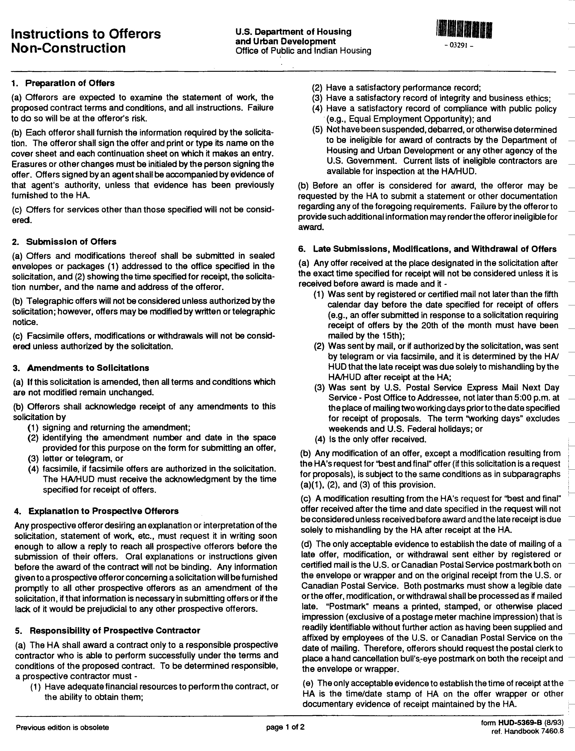
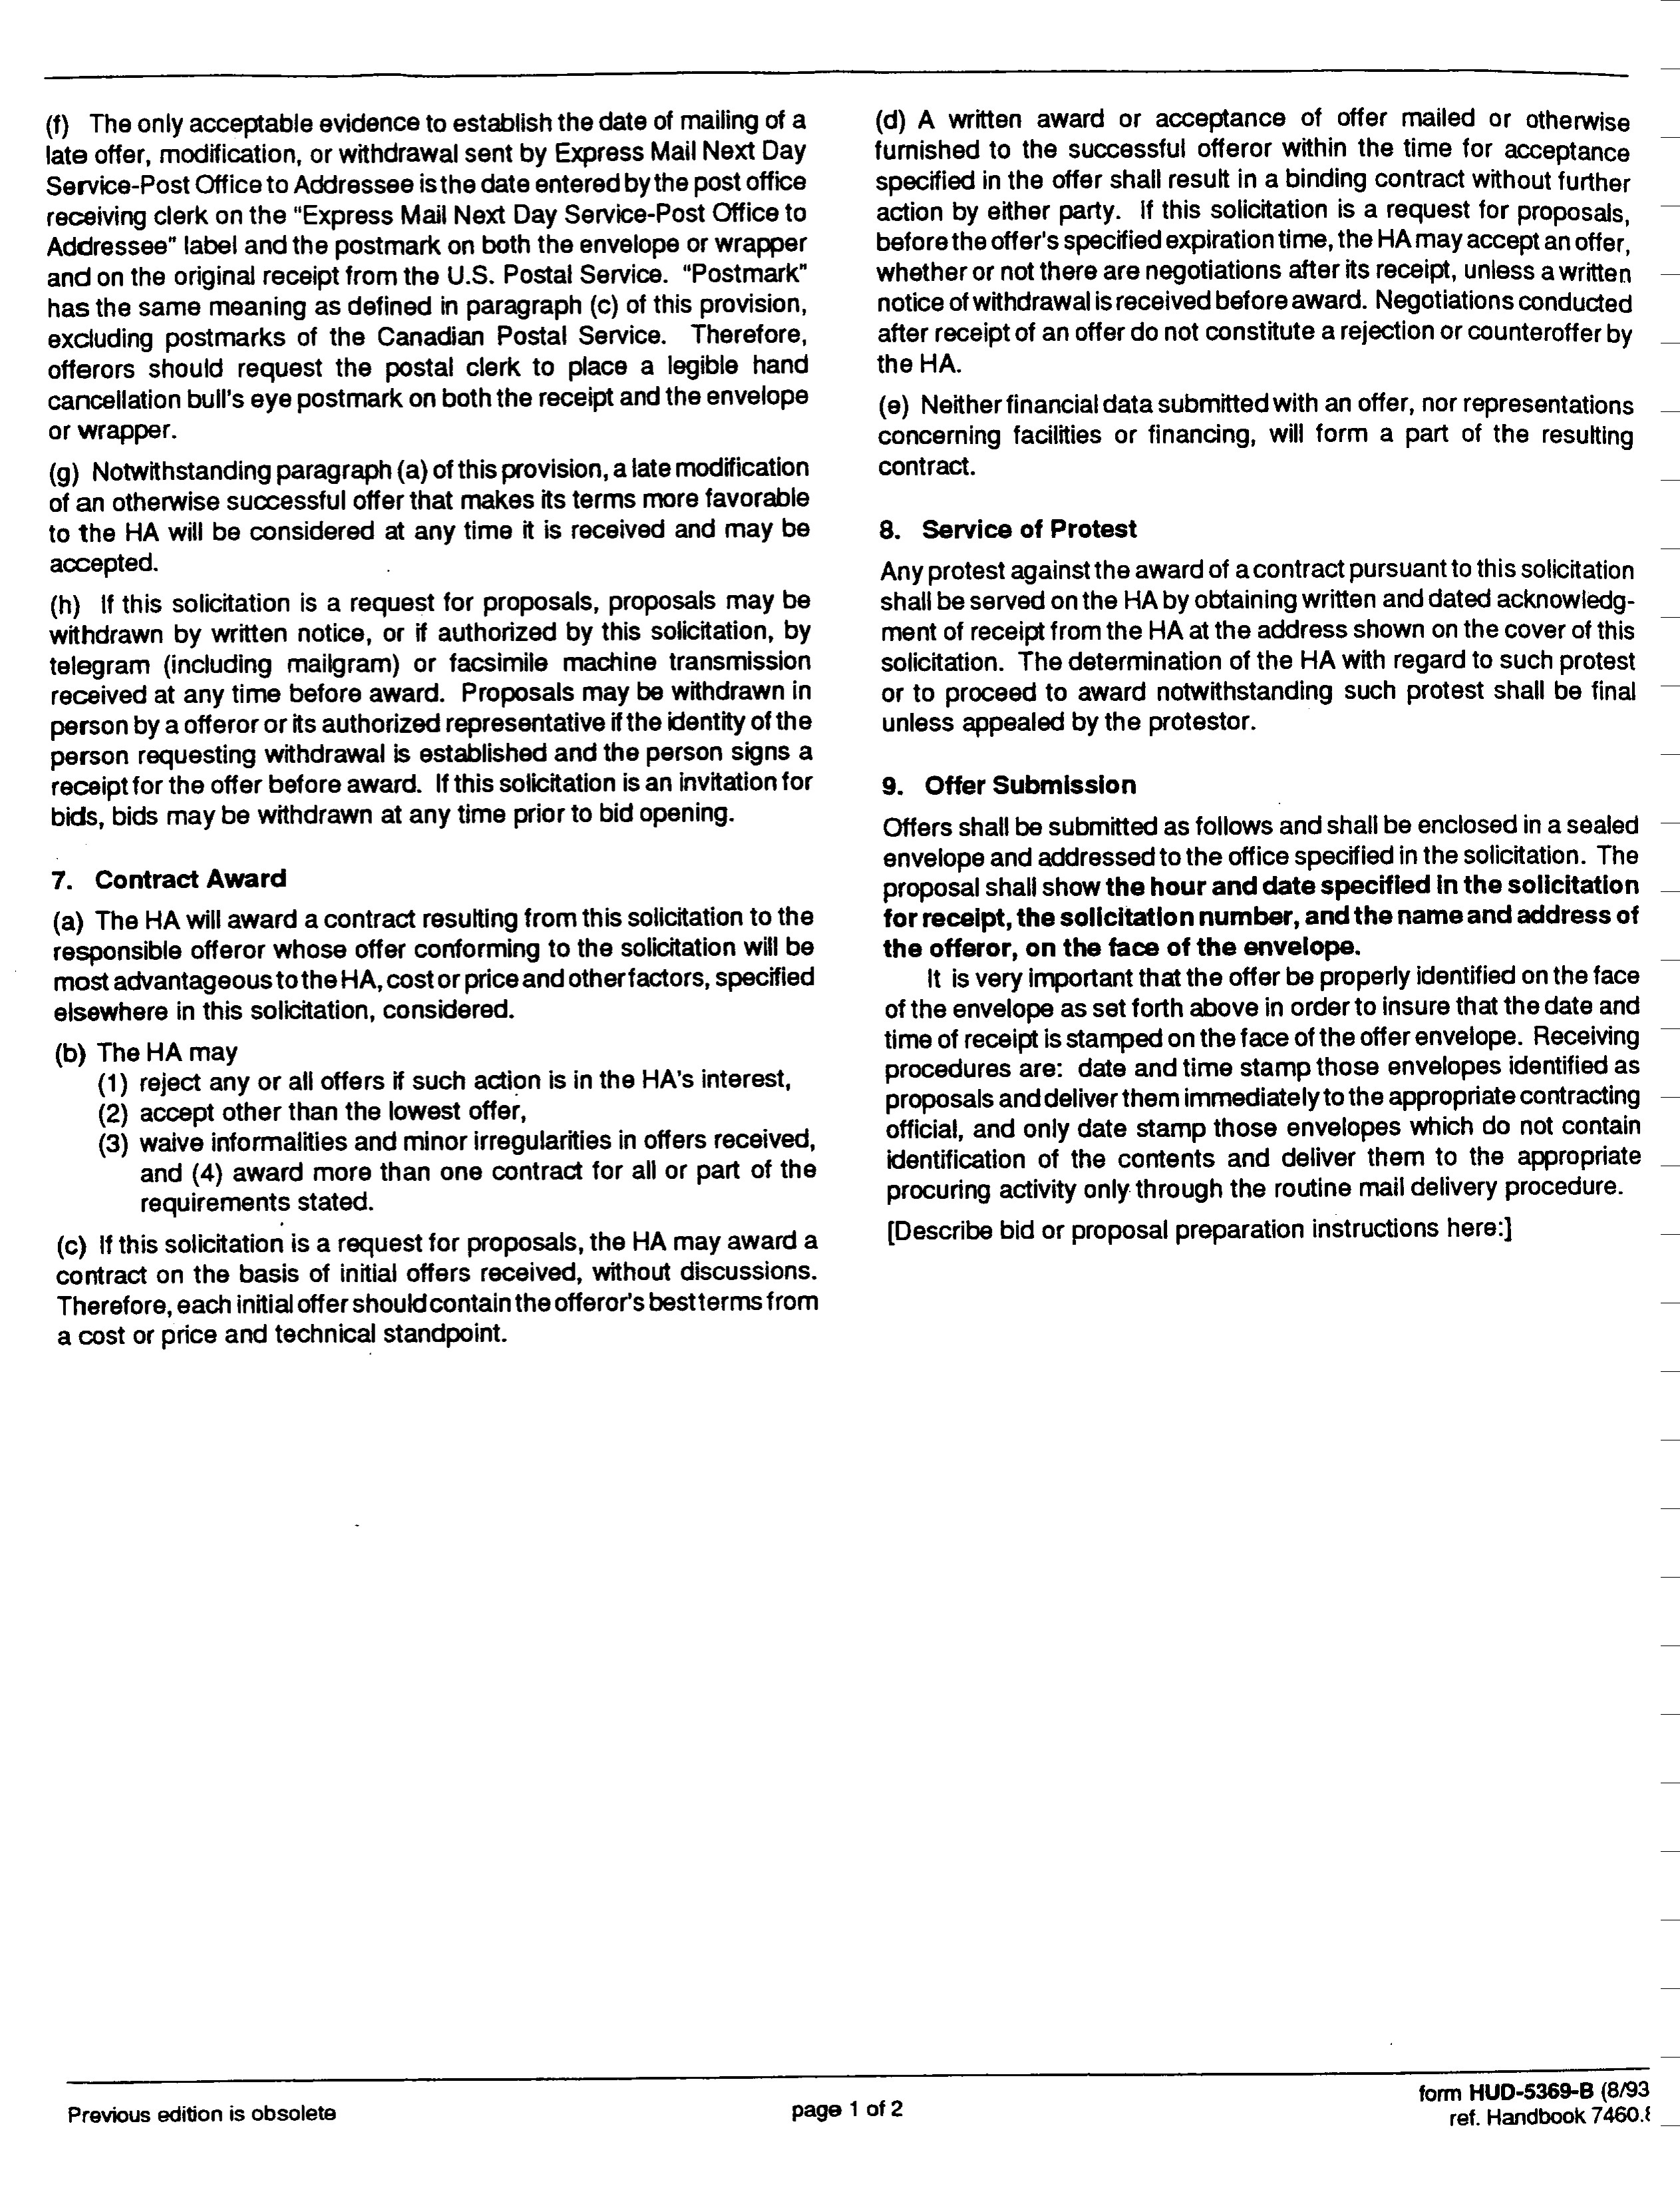
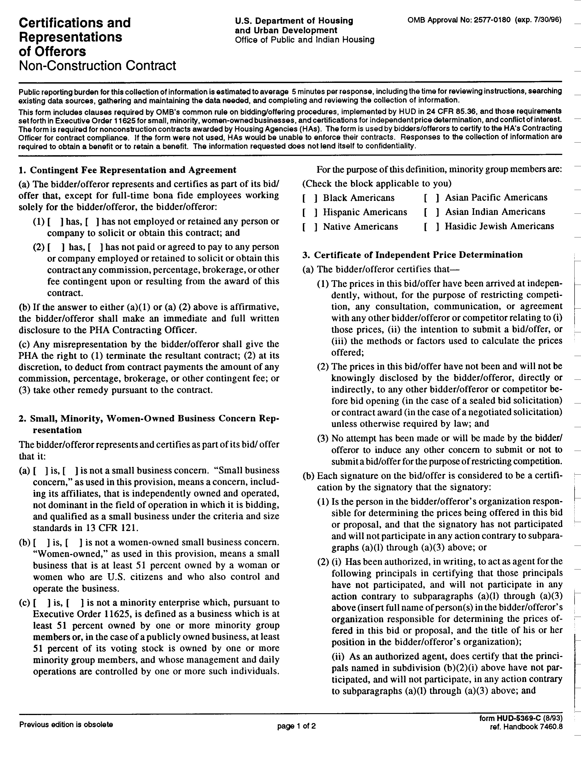
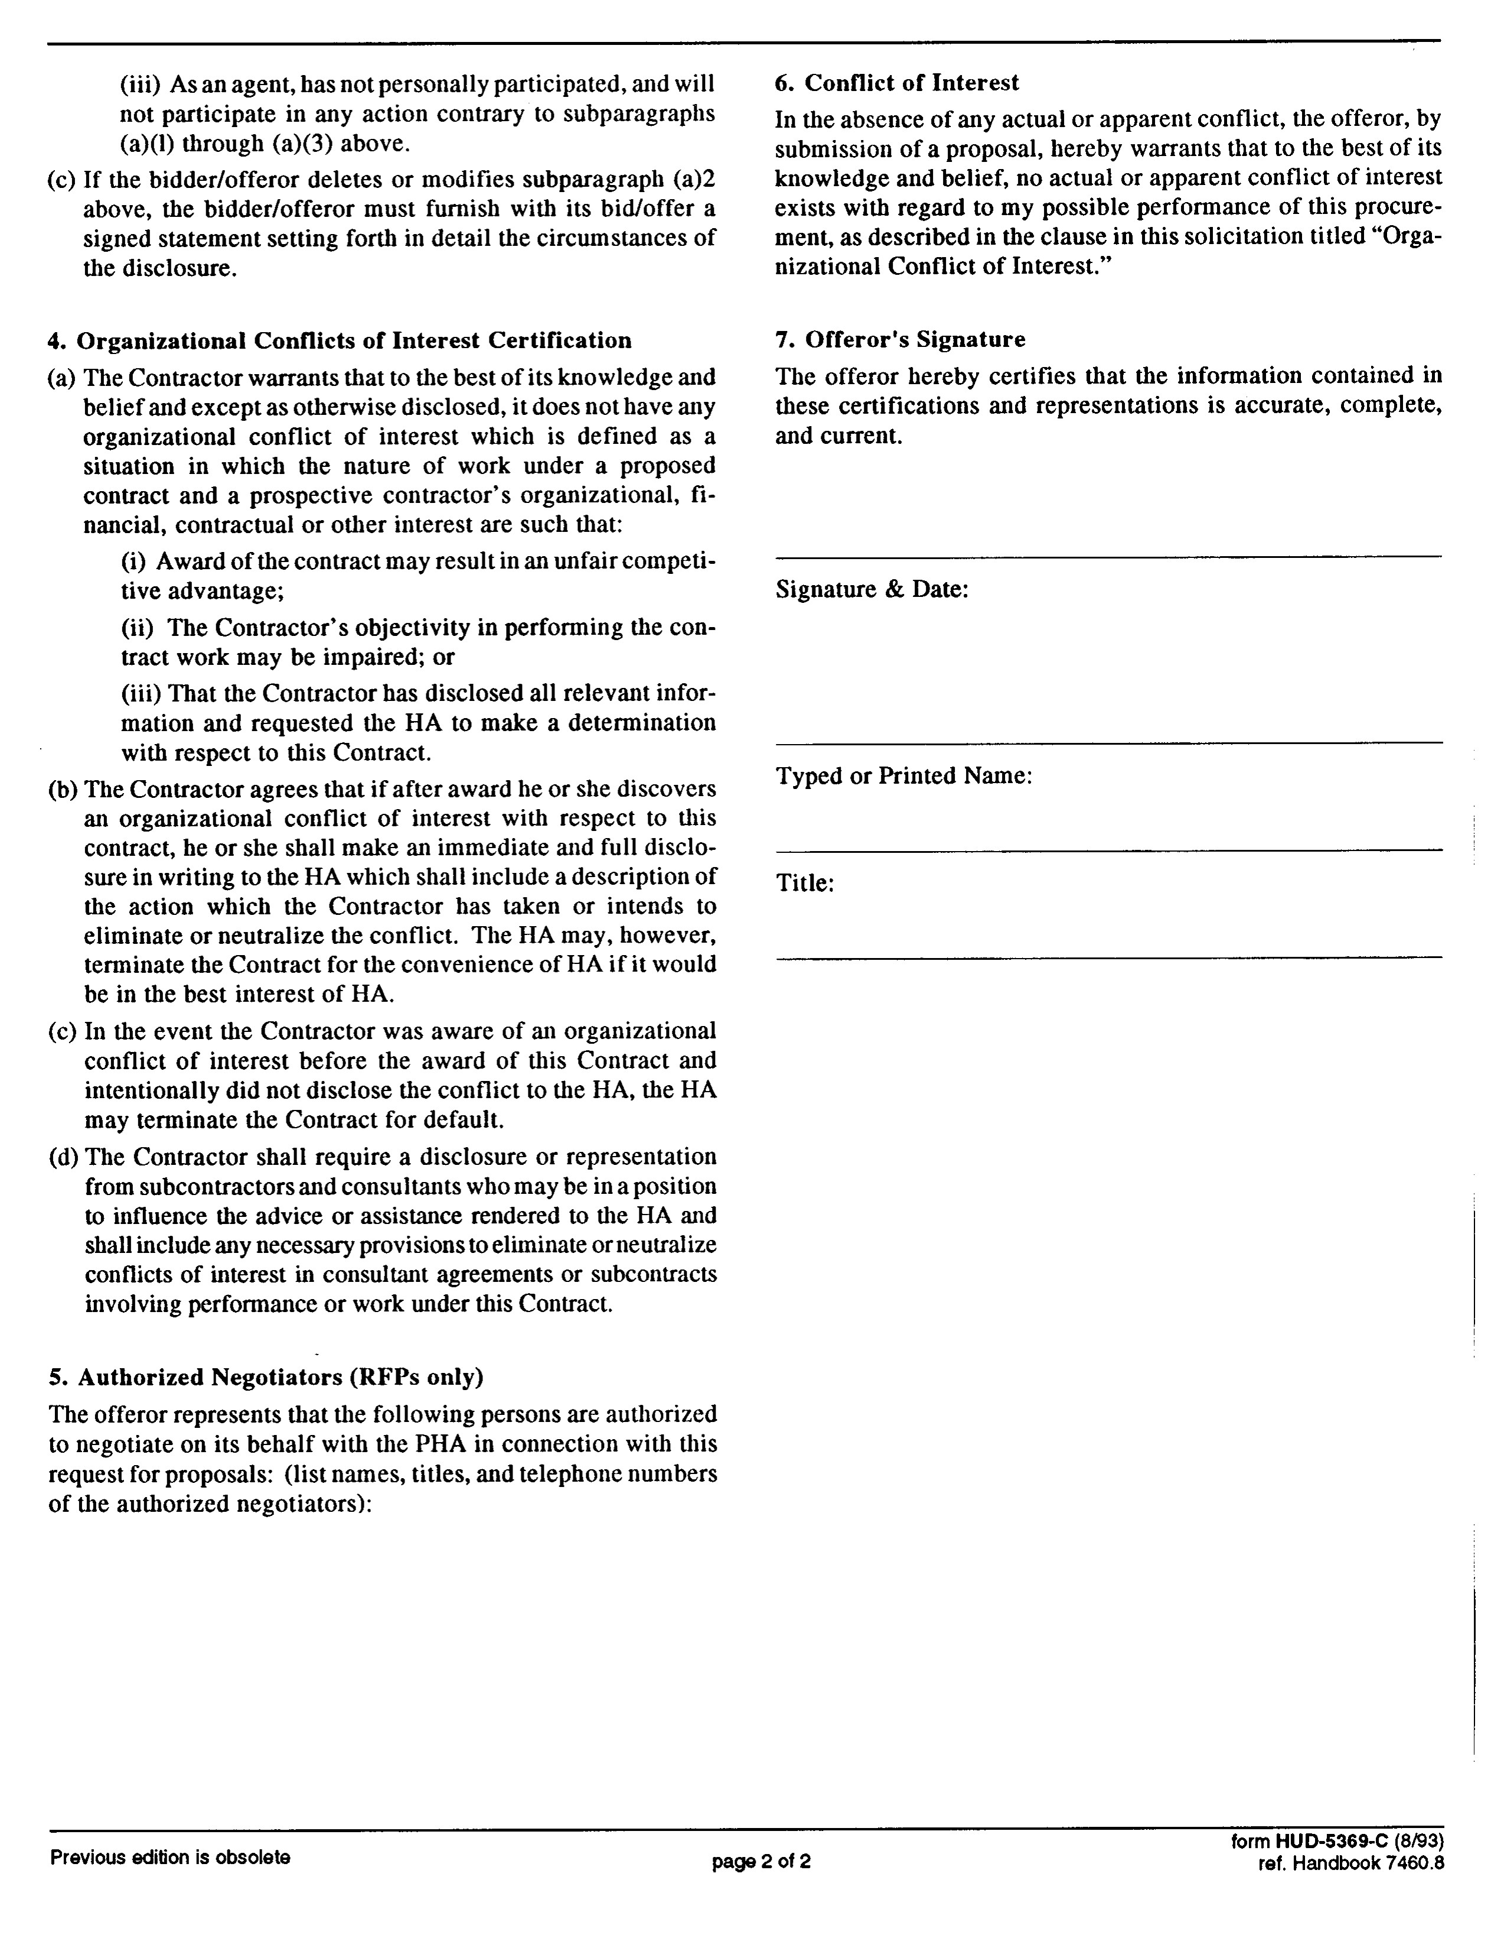

EXHIBIT B

THIS AGREEMENT made this _ day of __________, 2020 and executed by and between, THE MUNICIPAL HOUSING AUTHORITY FOR THE CITY OF YONKERS, a municipal housing authority duly authorized and validly existing under the laws of the State of New York and having offices and its principal place of business at 1511 Central Park Avenue, Yonkers, New York 10710, hereinafter called the “MHACY” and _ at , a corporation, individual, partnership, and/or joint venture, organized and existing under the laws of the State of New York, hereinafter called the “Contractor”.
Services pursuant to this contract shall begin on the day of , 2020, and shall end on the day of , 202 , unless otherwise extended modified, terminated or renewed by the parties as provided for within this contract.
WHEREAS, MHACY owns and/or manages properties at the following locations:
- Curran Homes, 4 Curran Court, Yonkers, NY
- Raleigh Valentine Townhomes 162 Helena Avenue
- Francis Reagan Townhomes 1157 Central Park Avenue
- James O’Rourke Townhomes 525 Shoreview Drive
- Judge Albert Fiorillo Townhomes 1 Lauring Avenue
- Arthur J. Doran Townhomes 1171 Midland Avenue
- Judge Albert Fiorillo Townhouses, 38 Clark Street

hereinafter “the Property”; and

WHEREAS, MHACY is in need of landscaping services at the Property (the “Work”); and
WHEREAS, MHACY issued Request for Proposal (“RFP”) # 2020 – 09 for the Work; and
WHEREAS, Contractor submitted a proposal and after due investigation was determined to be the lowest responsible bidder for the provision of the Work; and
NOW THEREFORE, in consideration of the matters above recited, the parties hereto formally covenant, agree and bind themselves as follows:
ARTICLE 1. STATEMENT OF WORK: Via the terms of this agreement the Contractor shall provide the Work at the Property as described herein and within the Exhibits/Appendices annexed to this contract. All personnel shall appear in uniform, shall be professionally trained, and shall have any and all necessary licenses or permits to provide the Work as the same may be issued by the State of New York, City of Yonkers or County of Westchester. In addition, the MHACY shall retain the right to implement and/or enforce any item issued as a part of Proposal submitted by Contractor entitled “Bid for Landscaping Services”.
ARTICLE 2. THE CONTRACT PRICE: MHACY agrees to pay the

Contractor for the Work, for the term of the Contract, as follows:
ARTICLE 3. THE CONTRACT TERM. The contract term for this contract shall be for the period 2020 through , 202 , unless otherwise extended modified, terminated or renewed by the parties as provided for within this contract.
ARTICLE 4. CONTRACT DOCUMENTS: The Contract consists of the following parts:
- This Agreement;
- Exhibit A (Scope of Work);
- Signed Copy of Contractor’s Bid;
- Drug-Free Workplace Certificate
- Signed Copy of Contractor’s Non-Collusive Affidavit
- HUD Form 2992 entitled “Certification Regarding Debarment and Suspension”
- HUD form 5369b entitled “Instructions to Offerors Non-Construction”
- HUD Form 5370-C entitled “General Conditions for Non-Construction Contracts”;
- Signed Copy of HUD Form 2530, Previous Participation Certificate; and
- Insurance Certificates (Workers’ Compensation; Commercial General Liability; and Automobile (if applicable)).
ARTICLE 5. PAYMENTS TO CONTRACTOR
a. Payments will be made as at the end of each calendar month on invoices for work performed and approved by the Contracting Officer for MHACY.
b. The terms of the contract are contingent upon sufficient appropriations. The MHACY's decision as to whether sufficient appropriations and authorization are made shall be accepted by the contractor and shall be final.
c. In no event shall the obligations of MHACY be a debt of the state of New York, nor the City of Yonkers.
ARTICLE 6. CONTRACTOR OBLIGATIONS Pursuant to this contract, the Contractor agrees to provide the specific services detailed herein and shall be responsible for the following:
a. MHACY Supervision and Oversight. The Contractor shall be solely responsible for providing supervision and oversight to all the Contractor’s personnel that are assigned to the MHACY properties pursuant to this contract. While engaged in the performance of the services described herein, only authorized employees of the Contractor are allowed at MHACY locations where the work is being performed. During the performance of these services, the Contractor employees are not to be accompanied in the work area by acquaintances, family members, associates or any other person(s) who are not
a current, authorized employee(s) of the Contractor.

b. Qualified Personnel. The Contractor warrants and represents that it will assign only qualified personnel to perform the services outlined herein and within the appendices. For the purposes of this contract, the term “qualified personnel” shall mean those personnel that have been investigated, tested, and trained in the manner described within this contract and, as proposed by the Contractor within its bid or as provided by the Contractor during the Contractor’s normal conduct of business.
c. Compliance with Federal and State Laws. All work performed by the

Contractor, pursuant to this contract, shall be done in accordance with applicable all Federal, State, and local laws, regulations, codes, and ordinances.
ARTICLE 7. INSURANCE REQUIREMENTS

a.) Indemnity: The Contractor shall protect, indemnify and hold harmless MHACY, its officers, directors, employees, agents, servants and representatives from and against any and all liabilities, obligations, claims, losses, damages, penalties, causes of action, costs and expenses (including reasonable attorneys’ fees, expenses and disbursements, and costs of investigation) imposed upon or incurred or asserted against MHACY, its agents, servants and representatives or to which MHACY, its officers, directors, employees, agents, servants and representatives may become subject, as a result of the negligent and/or illegal acts of the Contractor.
b.) Insurances. In this regard, the Contractor shall maintain the following insurance coverage during the effective term(s) of this contract:
i.) General Liability Insurance. An original certificate evidencing General Liability coverage, naming the MHACY as an additional insured, together with the appropriate endorsement to said policy reflecting the addition of the MHACY as an additional insured under said policy (minimum of $1,000,000 each occurrence, general aggregate minimum limit of $1,000,000, together with damage to premises and fire damage of $50,000 and medical expenses any one person of $5,000), with a commercially reasonable deductible (e.g. “commercially reasonable,” meaning not greater than 1% of the “general aggregate minimum” of the policy, with a maximum deductible amount of $50,000;
ii.) Professional Liability Insurance. An original certificate showing the proposer's professional liability and/or "errors and omissions" coverage (minimum of $1,000,000 each occurrence, general aggregate minimum limit of $1,000,000), with a commercially reasonable deductible (e.g. “commercially reasonable,” meaning not greater than 1% of the “general aggregate minimum” of the policy, with a maximum deductible amount of $75,000;
iii.) Automobile Liability Insurance. Automobile Liability coverage in a combined single limit of $1,000,000. For every vehicle utilized during the term of this contract, when not owned by the entity, each vehicle must have evidence of automobile insurance coverage with limits of no less than $100,000/$300,000 and medical pay of $5,000, with a deductible not greater than $5,000.

iv.) Worker's Compensation Insurance. Worker’s compensation coverage

evidencing carrier and coverage amount.

v.) Certificates/Endorsements. The Contractor shall provide to the MHACY with current certificate(s)/endorsement(s) evidencing the insurance coverage referenced above. Failure to maintain the above-referenced insurance coverage, including naming the MHACY as an additional insured (where appropriate) during the term(s) of this contract shall constitute a material breach thereof. All insurance shall be carried with companies which are financially responsible and admitted to do business in New York State. If any such insurance is due to expire during the contract period, the Contractor and subcontractors shall not permit the coverage to lapse and shall furnish evidence of coverage to the Contracting Officer. All certificates of insurance, as evidence of coverage, shall provide that no coverage may be cancelled or non-renewed by the insurance company until at least 30 days prior written notice has been given to the Contracting Officer. Insurance certificate(s)/endorsement(s) shall be delivered to the following person representing the MHACY:
Municipal Housing Authority for the City of Yonkers
Attention: Lakisha Collins-Bellamy, Esq.
1511 Central Park Avenue, Yonkers, NY 10710

ARTICLE 8. ASSIGNMENT OF CONTRACT: The Contractor shall not assign, transfer, convey, sublet or otherwise dispose of this Contract to any person, company or corporation, without the previous consent in writing of MHACY which consent may be withheld, conditioned or delayed. If the contractor shall, without the said previous written consent of MHACY, assign, transfer, convey, sublet or otherwise dispose of this Contract, or the Contractor’s title or interest herein, or the contractor’s owner to execute this Contract, to any other person, company or other corporation, then MHACY shall be relieved and discharged from any and all liability and obligations growing out of this Contract to such Contractor and to the person, company or corporation to whom the Contract was assigned, transferred, conveyed, or sublet to, and the Contractor and the Contractor’s assignee, transferee, or sublessee shall forfeit and lose all monies theretofore earned under this Contract.
ARTICLE 9. LEGAL ACTION: As part of the consideration for MHACY entering into this Contract, the Contractor hereby agrees that litigation between them may be brought only in courts located within the State of New York and the Contractor consents to the jurisdiction of any such court located within the State of New York, and further agrees to the venue of any such court as may be chosen by the MHACY. The Contractor waives the personal service of any and all process upon the Contractor, and consents that all such services of process may be made by certified mail, return receipt requested, directed to the Contractor at the address herein stated.
ARTICLE 10. FULL AGREEMENT: This Contract constitutes the full understanding of the parties, and may not be amended or modified except in writing signed by both parties. If there is a conflict between the Contract and any other writing signed by both parties, it is specifically agreed that this Contract will govern, whether such conflicting documents are prior to or subsequent to this Contract, unless each subsequent writing specifically enumerates it is in place of all or part of this Contract.
ARTICLE 11. GOVERNING LAW: The interpretation, validity and enforcement of this Contract shall be governed by and construed under any and all present and future local, state and federal laws, statutes, rules and regulations (“Laws”); and in the
event of a conflict between this Contract and the said Laws, then the latter shall control.
ARTICLE 12. TERMINATION OF CONTRACT: If the Contractor should be adjudged bankrupt, or if it should make a general assignment for the benefit of its creditors, or if a receiver should be appointed on account of its insolvency, or it should persistently or repeatedly refuse or fail to supply enough properly skilled workers or proper materials, or if it should fail to make prompt payment to its employees or approved subcontractors, or persistently disregard instructions of MHACY or fail to observe or perform the provisions of this Contract, or otherwise be guilty of a substantial violation of any provision of this Contract, then MHACY may, without prejudice to any other rights or remedies of MHACY, terminate this Contract.
ARTICLE 13. NOTICES:

a. CONTRACTOR RESPONSIBILITY - Any notice to MHACY must be in writing, delivered to MHACY’s central office, or sent by certified mail, return receipt requested, address to MHACY at the address listed above.
b. MHACY RESPONSIBILITY – Notice to the Contractor must be in writing, delivered to the Contractor, or sent by certified mail, return receipt requested, address to the Contractor at the address listed above.
c. All notices shall be deemed delivered:

(1) Personal Service: upon personal services. (2) Certified Mail Return Receipt Requested:
(i) If delivered, upon the date it is received and signed for by a recipient. (ii) If returned to MHACY as undelivered, upon the date affixed to the
certified mail receipt by the Post Office at the time of mailing.

ARTICLE 14. SEVERABILITY: If any provision of this Contract or the application of any provision of this Contract is held invalid, the remainder of this Contract and the application of such provision, other than to the extent it is held invalid, will not be invalidated or affected thereby.
ARTICLE 15. SECTION HEADINGS: Section headings are for convenient reference only and shall not affect the meaning or have any bearing on the interpretation of this Contract.
ARTICLE 16. OTHER CONTRACTS: MHACY may undertake or award other contracts for additional work at or near the site of the work under this Contract. The Contractor shall fully cooperate with the other contractors and with MHACY employees and shall carefully adapt scheduling and performing the work under this Contract to accommodate the additional work, heeding any direction that may be provided by the Contracting Officer. The Contractor shall not commit or permit any act that will interfere with the performance of work by any other contractor or by MHACY employees. However, it shall be noted that although MHACY employees may offer assistance and direction in some instances, final authority for proceeding in any matter rests with the
Contracting Officer.

ARTICLE 17. PERMITS AND CODES: The Contractor shall give all notices and comply with all applicable laws, ordinances, codes, rules and regulations.
ARTICLE 18. HEALTH, SAFETY AND ACCIDENT PREVENTION: In performing this Contract, the Contractor shall:
a. Ensure that no employee shall be required to work in surroundings or under working conditions which are unsanitary, hazardous, or dangerous to his/her health and/or safety.
b. Prevent damage to property, materials, supplies, and equipment; and c. Avoid work interruptions.

ARTICLE 19. ORDER OF PRECEDENCE: In the event of a conflict between the Contract and any applicable state or local law or regulation, the state or local law or regulation shall prevail; provided that such state or local law or regulation does not conflict with, or is less restrictive than applicable federal law, regulation, or Executive Order. In the event of such a conflict, applicable federal law, regulation, and Executive Order shall prevail.
ARTICLE 20. EXAMINATION AND RETENTION OF CONTRACTOR’S RECORDS:

a. MHACY shall, until 3 years after final payment under this Contract, have access to and the right to examine any of the Contractor’s directly pertinent books, documents, papers, or other records involving transactions related to this Contract for the purpose of making audit, examination, excerpts and/or transcriptions.
b. In addition to the above, the Contractor agrees to deliver the Contractor’s payroll records to MHACY every quarter for the purpose of making audit, examination, excerpts and transcriptions.

[BALANCE OF PAGE INTENTIONALLY BLANK]

[SIGNATURE PAGE TO CONTRACT]

IN WITNESS WHEREOF, the parties hereto have caused this Instrument to be

executed in four (4) original counterparts as of the day and year first above written.

Seal:

(Contractor)

Attest:

By

Title_

Business Address:

(Street)

(City) (State) (Zip)

Attest:
THE MUNICIPAL HOUSING AUTHORITY FOR THE CITY OF YONKERS
(MHACY)

By
WILSON KIMBALL
Contracting Officer

Business Address:

1511 Central Park Ave., P.O. Box 35

Yonkers, New York 10710
(City) (State) (Zip)_

CERTIFICATION

I, , certify that I am the

of the corporation, or a General Partner or Managing Partner of the partnership, named as Contractor in the attached Agreement: that , who signed this Agreement on behalf of the Contractor, was then of that corporation or partnership; that I know his signature, and his signature is genuine; and that the Agreement was duly signed, sealed, and attested for and on behalf of that corporation or
partnership by authority of its governing body or partners.

Signed by the Secretary or Other Authorized Officer
Of the Corporation or By General or Managing Partner

Name of the Corporation or True Name of the Partnership

Corporate
Seal

VERIFICATION

STATE OF NEW YORK) COUNTY OF

)s.:

On this day of , 2020, before me personally appeared
(Contractor who executed the Agreement), to me known and known to me to be the individual described in and who executed the foregoing Agreement, and he/she duly acknowledged to me that he/she executed the same.

NOTARY PUBLIC

CERTIFICATION

I, WILSON KIMBALL, certify that I am the Executive Director of The Municipal Housing

Authority for the City of Yonkers, named as MHACY in the attached Agreement and that I

am authorized to execute the Agreement on behalf of MHACY.

Wilson Kimball, CEO and President

The Municipal Housing Authority for the
City of Yonkers

VERIFICATION

STATE OF NEW YORK)
COUNTY OF WESTCHESTER)s.:

On this day of , 2020, before me personally appeared WILSON KIMBALL, to me known and known to me to be the individual described in and who executed the foregoing Agreement, and she duly acknowledged to me that she executed the same.

NOTARY PUBLIC

