SPECIFICATIONS FOR KITCHEN CABINET REPLACEMENT
TALLAHASSEE HOUSING AUTHORITY SPRINGFIELD APARTMENTS

PART 1 - GENERAL
A. DEVELOPMENT. Springfield Housing Complex was constructed in August 31, 1997 and it consists of 80 Buildings: 34 one bedroom units, 68 two bedroom units, 56 three-bedroom units, 28 four bedroom units and 8 five-bedroom units. They are multi-family, detached buildings with open porch & wood siding finish.

B. SCOPE OF WORK
l . Remove existing kitchen cabinets, including all applicable moldings, trim, range hood, existing vent, counter top, sink, p-trap, dishwasher connection and finish work as necessary to remove and replace the millwork.
2. Furnish all labor, materials, equipment and perform all work required to replace Kitchen Cabinets complete, including Counter Tops, Splashes and Door Hardware.
3. Inspect for underlying damages and Repair /Replace all rotten blocking, studding, drywall and paint kitchen cabinets if necessary. Contractor to provide a per sq/ft Unit Price for drywall replacement included in Bid or Time & Materials
4. Provide Sink installation, basket strainer, including p-trap, 0-rings, end waste, cut off valves, drain extension pipes and water supplies lines. Provide temporary Sink service during the installation if necessary.
C. SUBMITTALS
l. Product Data: Submit product data for cabinets and counter tops to the Engineer for each type of kitchen.
2, Shop Drawings: Submit Shop Drawings for cabinets and counter tops to the Engineer for each type of kitchen.
- Samples: Submit samples of following to designated Housing Authority staff:
    - Wood Veneers with stain finishes
    - Plastic Laminate patterns and colors
4. Quality Assurance/Control Submittals: Submit following to designated Housing Authority staff:
A. Certificates: Manufacturer's written certification that cabinets and countertops meet or exceed specified requirements.

PART 2 - PRODUCTS
2.0 CONSTRUCTION TYPE.
The construction type shall be with solid hardwood material; HUD severe use kitchen cabinets are made to last. They meet the meticulous "Severe Use" specifications that guarantee long service life. These cabinets needs to be approved and certified by the Kitchen Cabinet Manufacturers Association. Produced to exceed the industry standards both for performance and construction, HUD Severe Use cabinetry is well-suited to public housing.
Basis for design is "KraftMaid". Substitutions will be considered upon submittal but are subject to the design criteria as follows:
    - Cases shall be constructed of3/4" plywood matching with face frame and doors,
    - Wall cabinets shall have a nominal 3/4¹ ' thick (18 mm) x 3" high multiply hardwood plywood, running full cabinet length at the top and bottom for secure installation.
    - Backs Panel shall be constructed of ¹/4 inch thick plywood Dadoed into sides and that shall be securely glued and nailed or stapled strongly to ends and handrails matching with face frame and doors.
    - All shelves are 3/4" plywood and adjustable with front edge hardwood bonded
(base cabinets should have 18 inches depth shelves).
    - Toe kicks shall be 2 inches deep minimum, 3-1/2 High removable treated solid pine treated wood stained to match the cabinet color.
    - Face frames shall be 3/4" thick solid red oak wood, 2 inches wide stiles Mortised and tensions joints, or pocket screwed and glued.
    - Doors shall be "Raised panel" style with a semi-gloss "Chestnut" finish. Alternate pricing for "Shaker" style doors and "Cognac" finish is required in the Bid Documents.
    - Hinges: Manufacturer's standard heavy duty with self-closing feature, face mount
or semi- concealed type.
    - Drawers. The front profile of the drawers should match the door's profile edge.
      - Drawer Parts: Glued and nailed or stapled together.
      - Mount Drawers on metal slide full extension rails with 34 kg (90 pound) loading capacity.
      - Cabinet Members or Guides: attached at rear to 19.1 mm (3/4 inch) solid lumber hanging rail or 12.7 mm (1/2 inch) solid lumber or plywood block which is attached to
19.1 mm (3/4 inch) solid lumber hanging rail by use of metal rear mount brackets or by continuous wraparound method,
2.1 NORMAL/ELDERLY/HUD SEVERE USE CABINETS
- Cabinets: Standard size factory manufactured, assembled and finished for normal/elderly and severe use as scheduled. Comply with:
  - HUD Minimum Property Standards for Housing.
  - ANSI/KCMA A 161. I Kitchen Cabinet Manufacturers Association)
- Cabinet Construction: Hardwood face frames and reveal overlay construction.
  - Base and Wall Cabinets: Same construction and same appearance.
  - Cabinet Doors: Base bid — Raised panel doors (style to be determined) Alternate # 1 - Shaker style Doors (SEE EXHIBIT "A")
- Cabinet Materials:
  - Plywood: ANSI/HPMA HP and ps 1. (SEE EXHIBIT “A”)
  - Pressure Treated Lumber: AWPA C2.
  - Cabinet Hardware: ANSI/BHMA A156.9.
a. Cabinet Hardware: Finishing requirements of ANSI/BHMA Al 56, corrosion resisting.
- Cabinet Finish: Comply with ANSI/KCMA Al 61.1 finish test and performance requirements
l. Exposed Surfaces and Interior of Cabinet: factory finished consisting of stain, sealer and top coat, lightly sanded between application. (SEE EXHIBIT "A")
    - Sealer and Top Coats: Oven dried.
    - Stain color: Selected by Engineer from manufacturer's standard colors.
  - Toe Kick: Painted as specified by the design specifications.
  - Alternate Finish: High-pressure Decorative Laminates (HPDL) may be supplied in lieu of finish described above.
a) HPDL: Comply with NEMA LD 3, Type GP 28, 0.7 mm (0.028 inch) thickness.
- Fillers and Molding: Use scribe mold and fillers to assure accurate job fit.
  - Molding and Fillers: Outside corners, scribes, cove molding, and trim molding.
  - Fillers: Include corner case fillers, base fillers, and wall fillers,
  - Cove Molding: Hardwood.
  - Finish: Match cabinet finish.
- Joint Sealant: Mildew resistant one-component silicone; FS TT-S-OOI 543A
  - Class A; ASTM cm, Type S, Grade NS, Class 25, Uses NT, G, and A.
  - Color: As selected by Engineer from manufacturer's standard line.
- Wall and Base Cabinets: Comply with requirements under Construction Type - General above. Construct to produce sturdy and rigid construction.
- Countertops: 3/4" Plywood base with 1-1/2" overhang and bullnose edge.
  - Laminate: Tumbled Roca with Standard Fine Velvet Texture Finish.
I, Backsplashes: Minimum 100 mm (4 inches) high with cove beveled molding with Type A curved top and scribe edge.
a. Provide backsplashes at juncture of countertop with back and side walls.
B. Materials: High pressure plastic laminated to 19.1 mm (3/4 inch) thick exterior plywood.
  - Particleboard, flakeboard, fiberboard, or hardboard not allowed.
  - Plastic Laminate: NEMA LD 3, Type PF42, 1.1 mm (0.042 inch) thickness.
  - Colors, patterns, finishes as selected from manufacturer's standard offering.
  - Perimeter of Bottom of Countertops and Sink Cut-outs: Sealed with varnish.

PART 3 - EXECUTION
A. EXAMINATION
Site Verification of Conditions:
- Existing Conditions: Examine spaces to verify that they are ready or demolition of the cabinetry and then to receive cabinets and counter- tops.
- Verify grounds, blocking and supports for proper location and support of cabinets before beginning installation. Verify location of mechanical and electrical rough-ins to assure proper match with in- stalled equipment.
- Survey each kitchen to verify dimensions for cabinets and countertops
B, PREPARATION
- Protection: Protect adjacent elements from damage and disfiguration in accordance with Section 01120.
- Repair or replace damaged elements in accordance with Section 01120.
- Remove and dispose of existing cabinets and countertops
- C. INSTALLATION
l. General: Deliver, uncrate, place in proper location and assemble cabinets and countertops in accordance with manufacturer's recommendations and approved Shop Drawings.
- Cabinets: Set cabinets accurately in place, level, and plumb.
  - Maintain distance between bottom of wall cabinets and top of countertop between 380 and 455 mm (1 5 and 1 8 inches).
  - Scribe and secure to floor and walls.
  - Provide connecting and attaching devices, closures, and trim members as required for complete installation.
  - Install items complete and adjust moving parts to operate smoothly.
  - Wall Cabinets: Hang from masonry walls or secure directly to wall studs.
  - Scribe and closely fit casework to adjacent work.
- Countertops: Secure to casework and walls with concealed fasteners.
  - Post-Formed Plastic Laminate Countertops: Miter inside corner joints.
  - Seal cut edge of plywood at sink opening with spar varnish.
  - Seal joints between countertops and walls with joint sealant,
- Sinks and Trim: Provided and installed per Code requirements. Install Sink, kitchen faucet, water supply lines, p-trap and cut-off valves in accordance to manufacturer's instructions.
- Plastic Laminate Splash: Install on wall full width of range from top of range to bottom of range hood and under wall cabinets. Secure to wall with appropriate adhesive.
- Replace outlets, switches, plastic covers and GFCI up to code as per city codes regulations and specifications.
- Install existing range hood in accordance to manufacturer's instructions.
- Install existing vent pipe in accordance to manufacturer's instructions.
D. DELIVERY, STORAGE AND HANDLING
1. Packing, Shipping, Handling and Uploading:
a. Do not deliver cabinets until building or storage area is enclosed and sufficiently dry to prevent damage from excessive changes in moisture content.
- WARRANTY.
The Contractor hereby warrants that all cabinets and accessories manufactured and sold hereunder by the contractor are free from defects in material and workmanship for a period of two years from the date of installation. All claims for defective cabinets and accessories must be submitted to the Contractor in writing and must specify the defects present in the cabinets and accessories.
- SAFETY AND CLEAN UP
Protect all of existing structure, shrubs, and tenant owned personal property during removal, taking caution to keep all entrances free of Hazards. Protect from weather at all times. All kitchen cabinets removed/replaced shall be the responsibility of the contractor to properly dispose of. Contractor shall clean all areas inside cabinets and drawers, caulked backsplashes and in the unit areas affected by the construction.

EXHIBIT "A"
CABINET MATERIALS / FINISH / STYLE
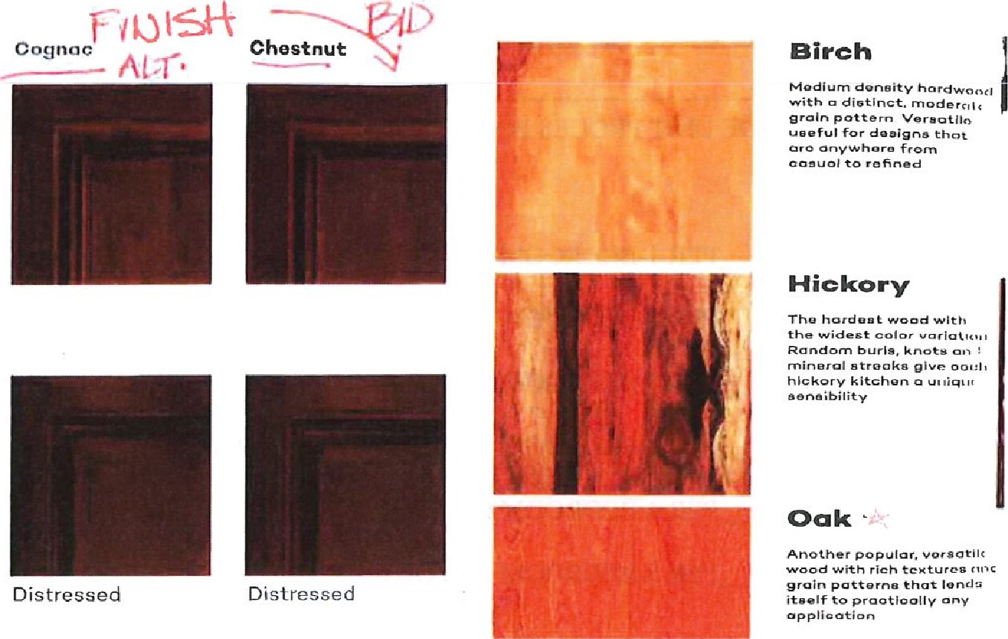

Some terms you're likely to hear.
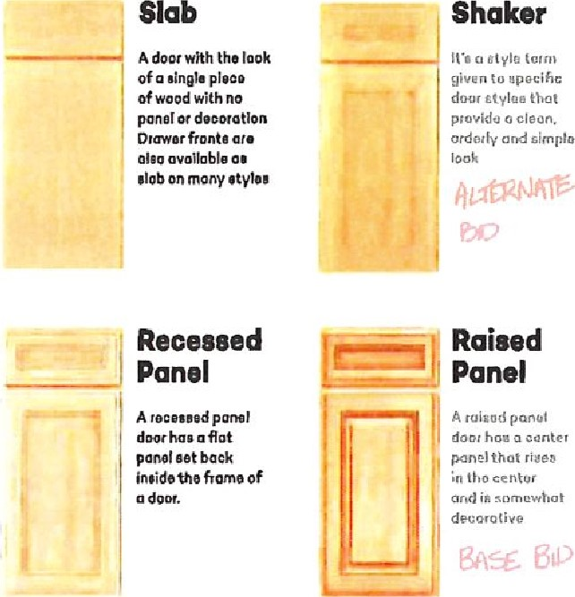

A ruitot'l panel hog canter panel that rider
decorative

