ALBUQUERQUE HOUSING AUTHORITY
RFP No. 2224
ROOF REPLACEMENT SERVICES
- Addendum Number: #1

- Issued By: Albuquerque Housing Authority

- Addendum of solicitation number: RFP No. 2224 dated: 07/05/2022

- The hour and date specified for receipt of bids/proposals is 3:00 pm on Wednesday, 13 July 2022 and is not extended through this addendum.

- The above-numbered solicitation is amended as set forth below. Bidders/offeror acknowledges receipt of this addendum through notification sent out through Economic Engine website.

- Description of amendments: Questions and Answers

Pre-Proposal Questions and Answers
- Have you tested the roofs for Asbestos? No AHA has not tested the roofs and per the RFP, “Asbestos test records are not available. Contractors will be responsible for following all health and safety regulations regarding the testing, handling and disposal of any roof materials that may be asbestos containing.”

- Does AHA have exact measurements of roofs? No AHA only has provided heated space square footage. Contract shall use satellite images or conduct site walkthroughs as needed.
- What is the required warranty for the roof installation? 20-30 year material manufacture warranty and at least 1 year of installer warranty.
- Can we propose to use of other materials outside the requested specifications in Section 2 Technical Scope and Specifications? Yes please submit under Tab 12 and include pricing as an alternative #1 on Attachment J- Roof Replacement Pricing Sheet.
- What is the required mil for the TPO? The RFP is amended from 60 mil to 45 mil. Quote the 60 mil as an alternate pricing.

Delete 60 mil TPO in all attachments.
Replace with 45 mil TPO.

Question From Economic Engine: Everguard Roofing LLC via Economic Engine
Date: 07/05/2022
- For calculating net free ventilation area, do we use 1/150 square feet of attic floor space or 1/300 square feet?
Response: 1/150 Code Minimum or industry standard.
- For a balanced roofing system, ventilation should equal at the under eave and at or near the ridge.
Response: Propose as alternate ventilation and cost.
* In this scope -all steep slope roofs have inadequate ventilation.
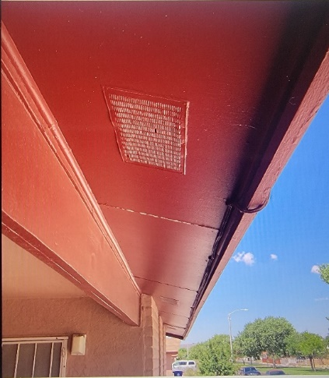
Will other trades install the necessary adequate under eave vents or can we use an above roof deck substitute?
Response: Yes use the roof deck as a substitute.
- Many evaporative cooler ducts have significant corrosion, will other trades replace them? Response: Yes, please provide pricing as an alternate.

- In cases where removing and replacing evaporative coolers are required, will a licensed contractor reinstall?

Response: Yes, AHA may have in house Plumber/Electrician replace or you can provide pricing (licensed employee or subcontractor) as an alternate.

If not, are we responsible for performance when the original condition is unknown?

Response: If you propose services as an alternate you would perform work if alternate work/pricing is selected/ awarded.

- Landscaping at different locations will make roof access and loading difficult, are we able to drive a forklift on the landscaping at any of these locations?

Response: Yes you will be able to drive a forklift or needed equipment to preform work.

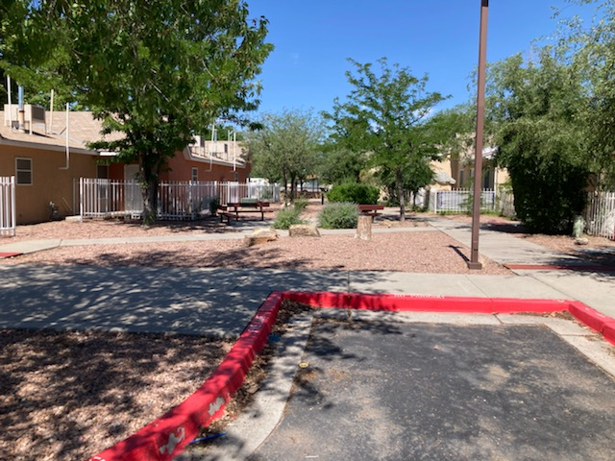

- Some locations have had newer stucco applied directly on top of shingles. With any shingle removal stucco damage is possible. Are we responsible for stucco repair?
Response: Yes please provide Estimate or third party repair.

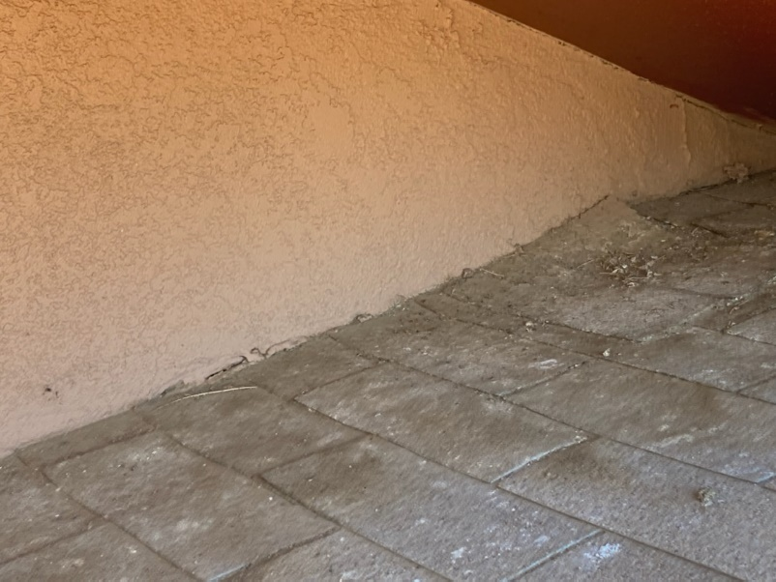

- Is there insulation in the cavity of the buildings or are we adding iso above the roof deck? What should the R Value be if adding iso above roof deck?
Response: You will be adding iso to the cavity; The R Value should be based on city code.
- At some locations there are pedestal A/C Units. These are not recommended because they can cause unforeseen issues. Will these units be replaced with leg stand units?

Response: They will be replaced by third party vendor or you can provide pricing as an alternate.
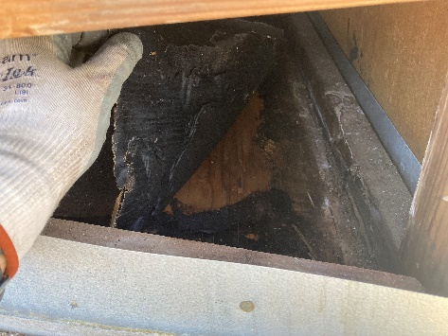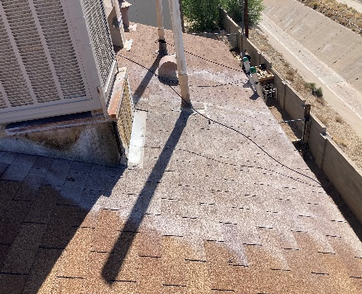

- Satellite dishes will need to be removed prior to installing the new roof system and will need to be reinstalled by others. Who will coordinate this, and can we request that these dishes NOT be roof mounted to avoid roof penetrations that may cause leaks?

Response: Roofers to remove. Tenant to coordinate ground mount installation with service provider. They should not be mounted on the roof per lease.

