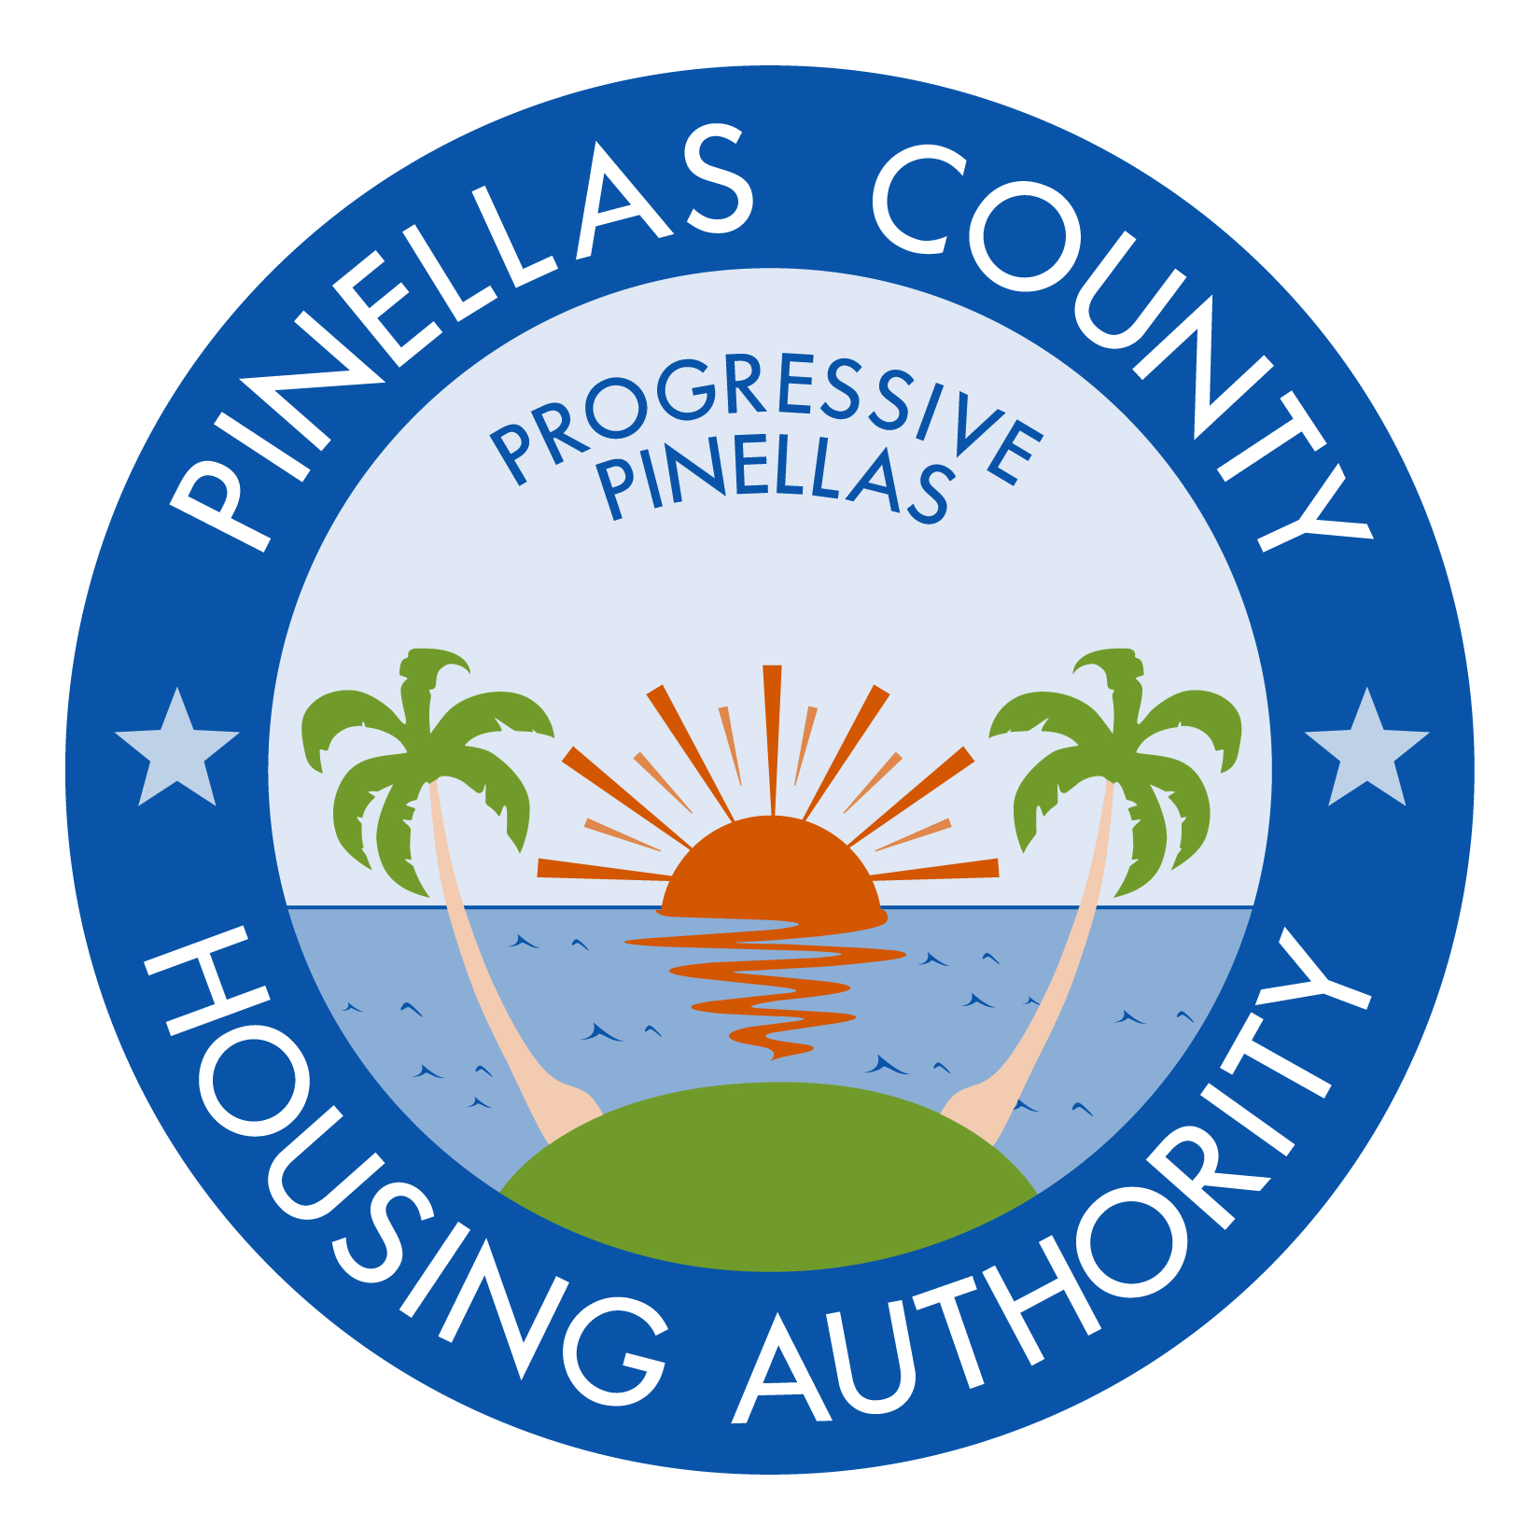

REQUEST FOR QUOTES DATED APRIL 25, 2017

ROOF REPLACEMENT AT PALM LAKE VILLAGE APARTMENTS (7 BUILDINGS)

ADDENDUM NUMBER ONE (1) MAY 5, 2017

A. INSTRUCTIONS:

- This addendum shall be included as part of the original Invitation for Bid documents and the scope of work required therein.

- Receipt of this addendum must be acknowledged by return of the fully executed “Acknowledgement of Receipt of Documents,” attached hereto, and must be submitted with the bid.

Any bids not including the “Acknowledgement of Receipt of Documents” form may be considered non-responsive.

B. CHANGE TO BUILDING ADDRESS:

Delete 1687 Leisure Lane. Replace with 1685 Leisure Lane.

C. CHANGE TO UNDERLAYMENT MATERIALS:

Delete Tiger Paw or approved equal. Replace with self-adhering underlayment.

D. CLARIFICATION TO BID PROPOSAL SUBMISSION:

Submit total bid proposal amount through the Housing Agency Marketplace. The website currently does not allow for contractors to upload additional documents. Email (to dleishman@pinellashousing.com), fax (to 727-489-0799), or hand-deliver your bid proposal on company letterhead with the total bid proposal amount and line-item pricing for addition or deletion of the following: ¾” plywood sheets, wood fascia (linear feet), and metal flashing (linear feet). Refer to page 6, item #3.02, D #1 and #3 for what allowances are to be included in base bid. Include submittals.

E. CLARIFICATIONS:

Refer to Request for Quotes dated April 25, 2017 (#17-001) Pre-Bid Minutes with Questions and Answers.

END OF ADDENDUM #1

REQUEST FOR QUOTES DATED APRIL 25, 2017

ROOF REPLACEMENT AT PALM LAKE VILLAGE APARTMENTS (7 BUILDINGS)

ADDENDUM NUMBER ONE (1) MAY 5, 2017

ACKNOWLEDGEMENT OF RECEIPT OF DOCUMENTS

All prospective firms for the above-referenced solicitation must sign this acknowledgement form as verification of receipt of the following documents:

- Addendum #1

NOTE: Each prospective bidder must submit this form with the submission package. Any bids not including this form may be considered non-responsive.

Acknowledged by: _____________________________________
Company Name

________________________________________
Printed Name of Authorized Company Official

________________________________________
Signature of Authorized Company Official

Date: ________________________

