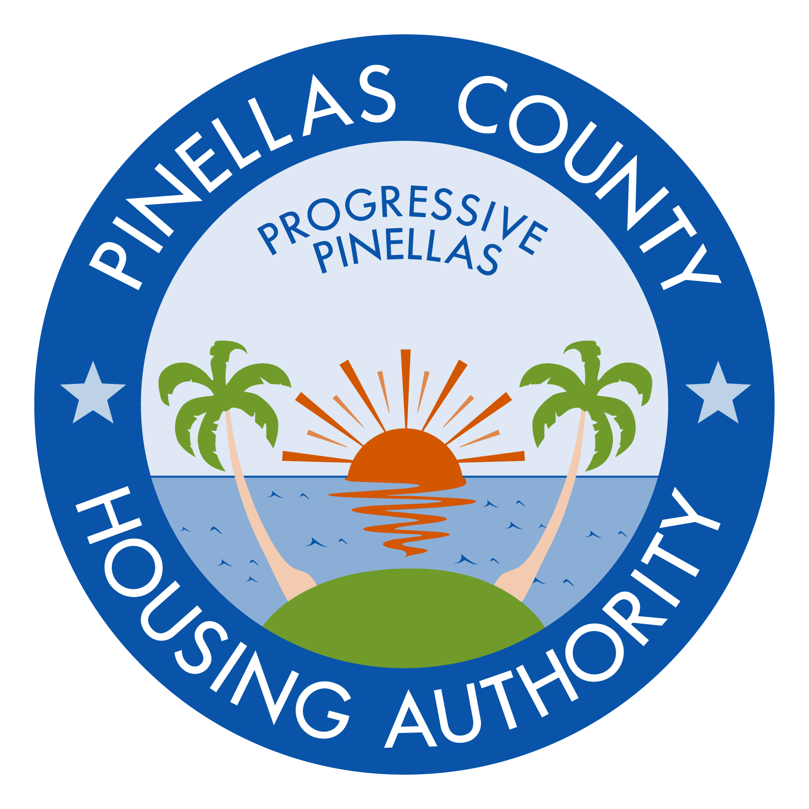

INVITATION FOR BIDS (IFB) # 18-004

ROOF REPLACEMENT AT CRYSTAL LAKES MANOR APARTMENTS (13 BUILDINGS)

ADDENDUM NUMBER ONE (1) APRIL 2, 2018

A. INSTRUCTIONS:

- This addendum shall be included as part of the original Invitation for Bid documents and the scope of work required therein.

- Receipt of this addendum must be acknowledged by return of the fully executed “Acknowledgement of Receipt of Documents,” attached hereto, and must be submitted with the bid.

Any bids not including the “Acknowledgement of Receipt of Documents” form may be considered non-responsive.

B. CHANGE TO BID DUE DATE:

The deadline for bids is extended to Wednesday, April 4, 2018 at 2:00 p.m.

END OF ADDENDUM #1

INVITATION FOR BIDS (IFB) # 18-004

ROOF REPLACEMENT AT CRYSTAL LAKES MANOR APARTMENTS (13 BUILDINGS)

ADDENDUM NUMBER ONE (1) APRIL 2, 2018

ACKNOWLEDGEMENT OF RECEIPT OF DOCUMENTS

All prospective firms for the above-referenced solicitation must sign this acknowledgement form as verification of receipt of the following documents:

- Addendum #1

NOTE: Each prospective bidder must submit this form with the submission package. Any bids not including this form may be considered non-responsive.

Acknowledged by: _____________________________________
Company Name

________________________________________
Printed Name of Authorized Company Official

________________________________________
Signature of Authorized Company Official

Date: ________________________

